**Los Angeles Parking Citations**

**Data Source:** <https://www.kaggle.com/cityofLA/los-angeles-parking-citations>

The dataset contains information about Los Angles Parking Violation.

The owner ship of this dataset belongs to City of Los Angeles, Dataset is open data. By analyzing this dataset we can answer not only parking citation problems but also we can gain information about the people who are more tend to violate these rules, their approximant wealth rate; if the location have enough warning, how much readable are these warning are, the people who comes from the other state which locations do they stay or visit.

**Dataset Description:**

The dataset is provided by City of Los Angeles. The dataset is updated daily.

More Information and Links about Attributes

Body Style: https://www.txdmv.gov/reports-and-data/doc_download/917-vtr-249-standard-abbreviations-for-vehicle-makes-and-body-styles

Issue time is recorded based on 24 hour clock <http://en.wikipedia.org/wiki/24-hour_clock>.

Zip file contains “LADOT-Xerox Crib Sheet Agency Codes 12-31-2015” file that shows which agency number represents the agencies.

The datasets location attribute have street address so using basic map of tableau doesn’t give us good visualization so we have embedded LA map from mapbox source: <https://www.mapbox.com/>

Dataset have 19 Attribute with 9.37m instances

**Ticket number**: Unique number of the citation that has been stored.

**Issue** **Date**: The format of the attribute is yyyy-MM-dd. Gives information about the citation Date.

**Issue** **time**: on a 24 hour clock <http://en.wikipedia.org/wiki/24-hour_clock>

**Meter** **Id:** Id of the park meter

**Marked** **Time**: time of the issued ticket

**RP State Plate**: 2 digit code of the states.

**Plate Expiry Date**: expiry date of the plate that has been cited

**VIN**: due to data anonymity this field is kept empty.

**Make**: the maker of the car.

**Body Style**: standard abbreviations of the vehicle body-style.

**Color:** 2 digit code of the colors.

**Location:** Los Angeles Street names.

**Route**: Route Number of record location.

**Agency**: Number that attended to Agency. Information about which agency has citied the ticket.

See About -> Attachments for a table of Agency Code to Agency Name.

**Violation code:** Code of violation description.

**Violation Description:** Short description what kind of violation made.

**Fine amount:** penalty price for violation.

**Latitude & Longitude:** Parking citations with latitude / longitude (XY) in US Feet coordinates according to the NAD_1983_StatePlane_California_V_FIPS_0405_Feet projection.

I have created custom attributes for better understanding the dataset.

**MeterNonMeter:** Attribute defines that is the citation written by park-meter or not.

**CaPlateNoneCa**: Attribute shows us if the vehicle is from California or from other state.

**Processing Dataset:**

For using Latitude/Longitude in map I have converted the US Feet coordinates to proper format that tableau can read by using R and created extra attributes for better analysis.

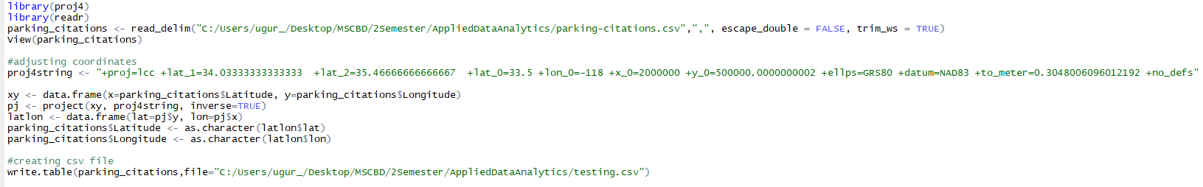

1.1-BodyStyle-Color

Sheet show us relation between Body styles and Color the shapes sizes changes according to Number of the Records. We can filter by color and Body style.

Does body type of vehicles and color have any effect on number of violations?

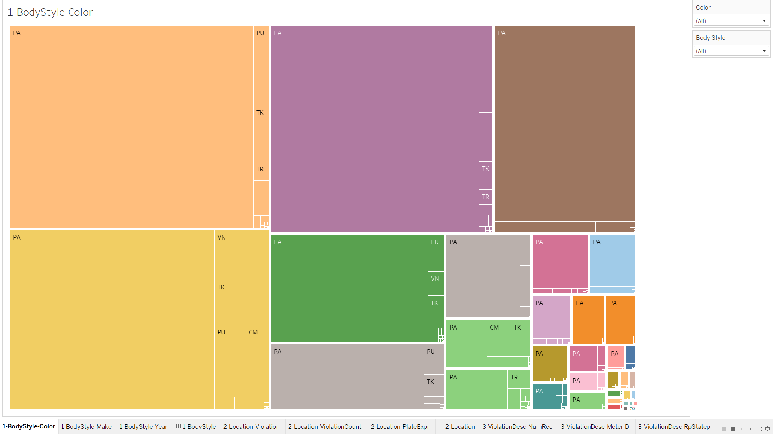

1.2- Body Style – Make

Sheet displays us the amount of citation, what type of vehicles and the make of the vehicles amount. The color shows us the distinct body styles we can observe that most of the violations made by Toyota, Nissan, and Honda made cars and all of their body style is same “PA”.

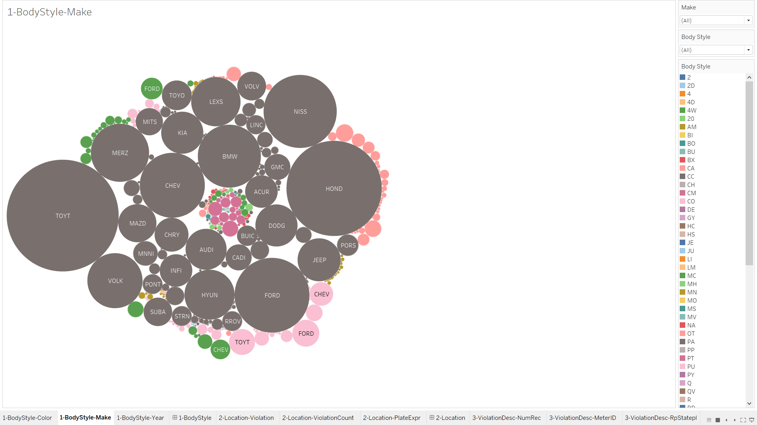

1.3- Body Style –Year

In this sheet right side shows year, left side shows number of records. We can observe that the vehicles which body style PA have most citations and nearly all years there have been violations with these body style vehicles.

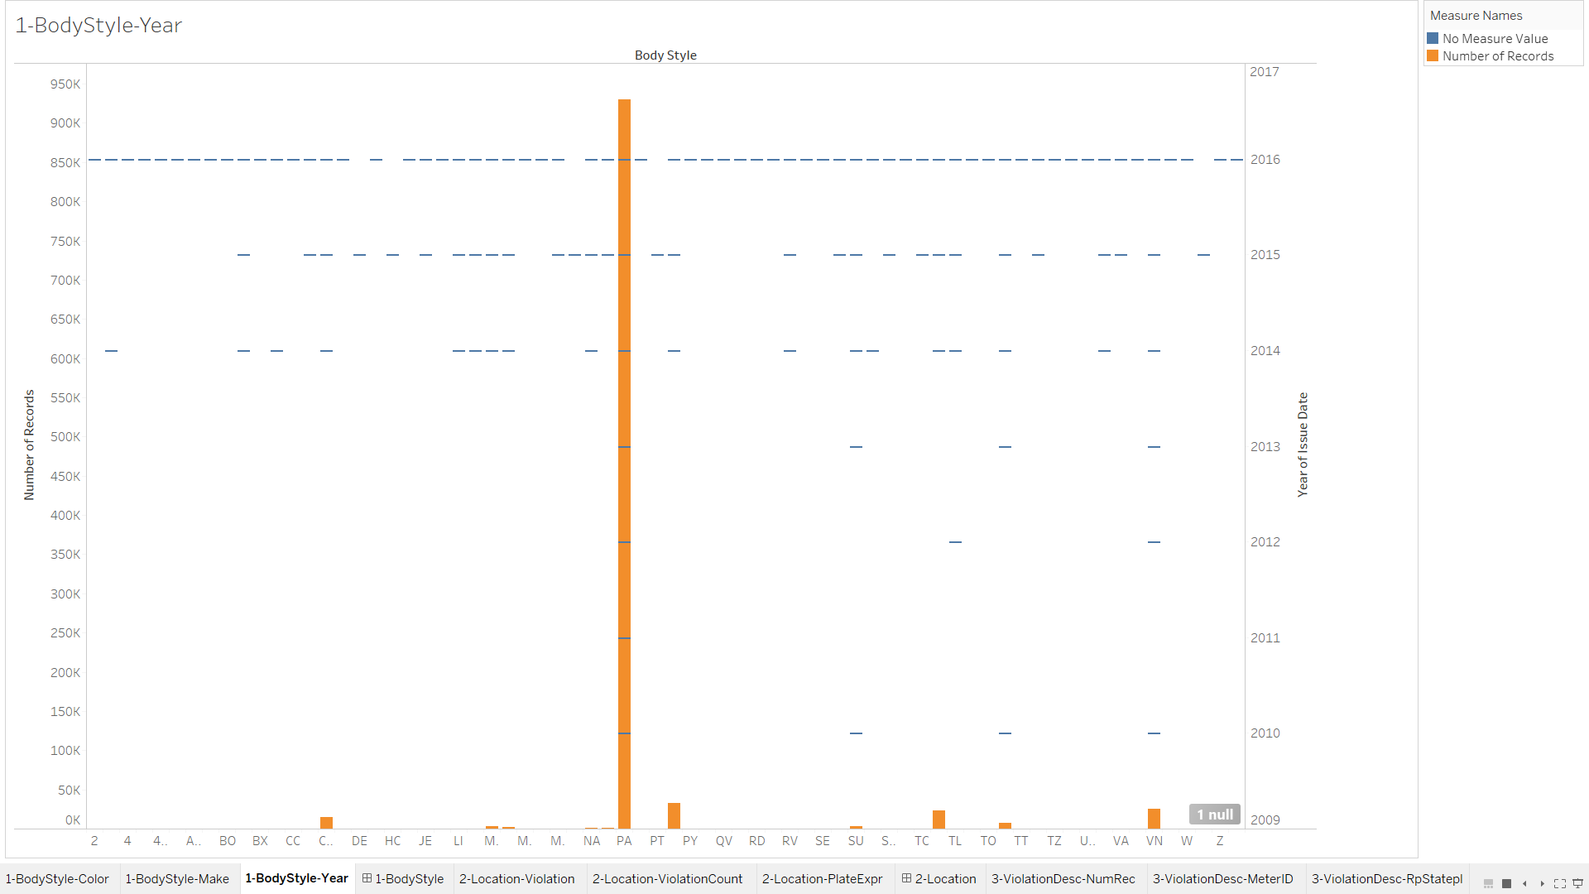

1-BodyStyle (Dashboard)

In this dashboard we can clearly visualize body style relation between vehicle related attributes, left upper shows relation between colors, right upper shows relation between vehicles maker and body style. Below sheet we can see that early year only PA body styled vehicles have violation, after 2014 violation of the other body-styled vehicles occurred.

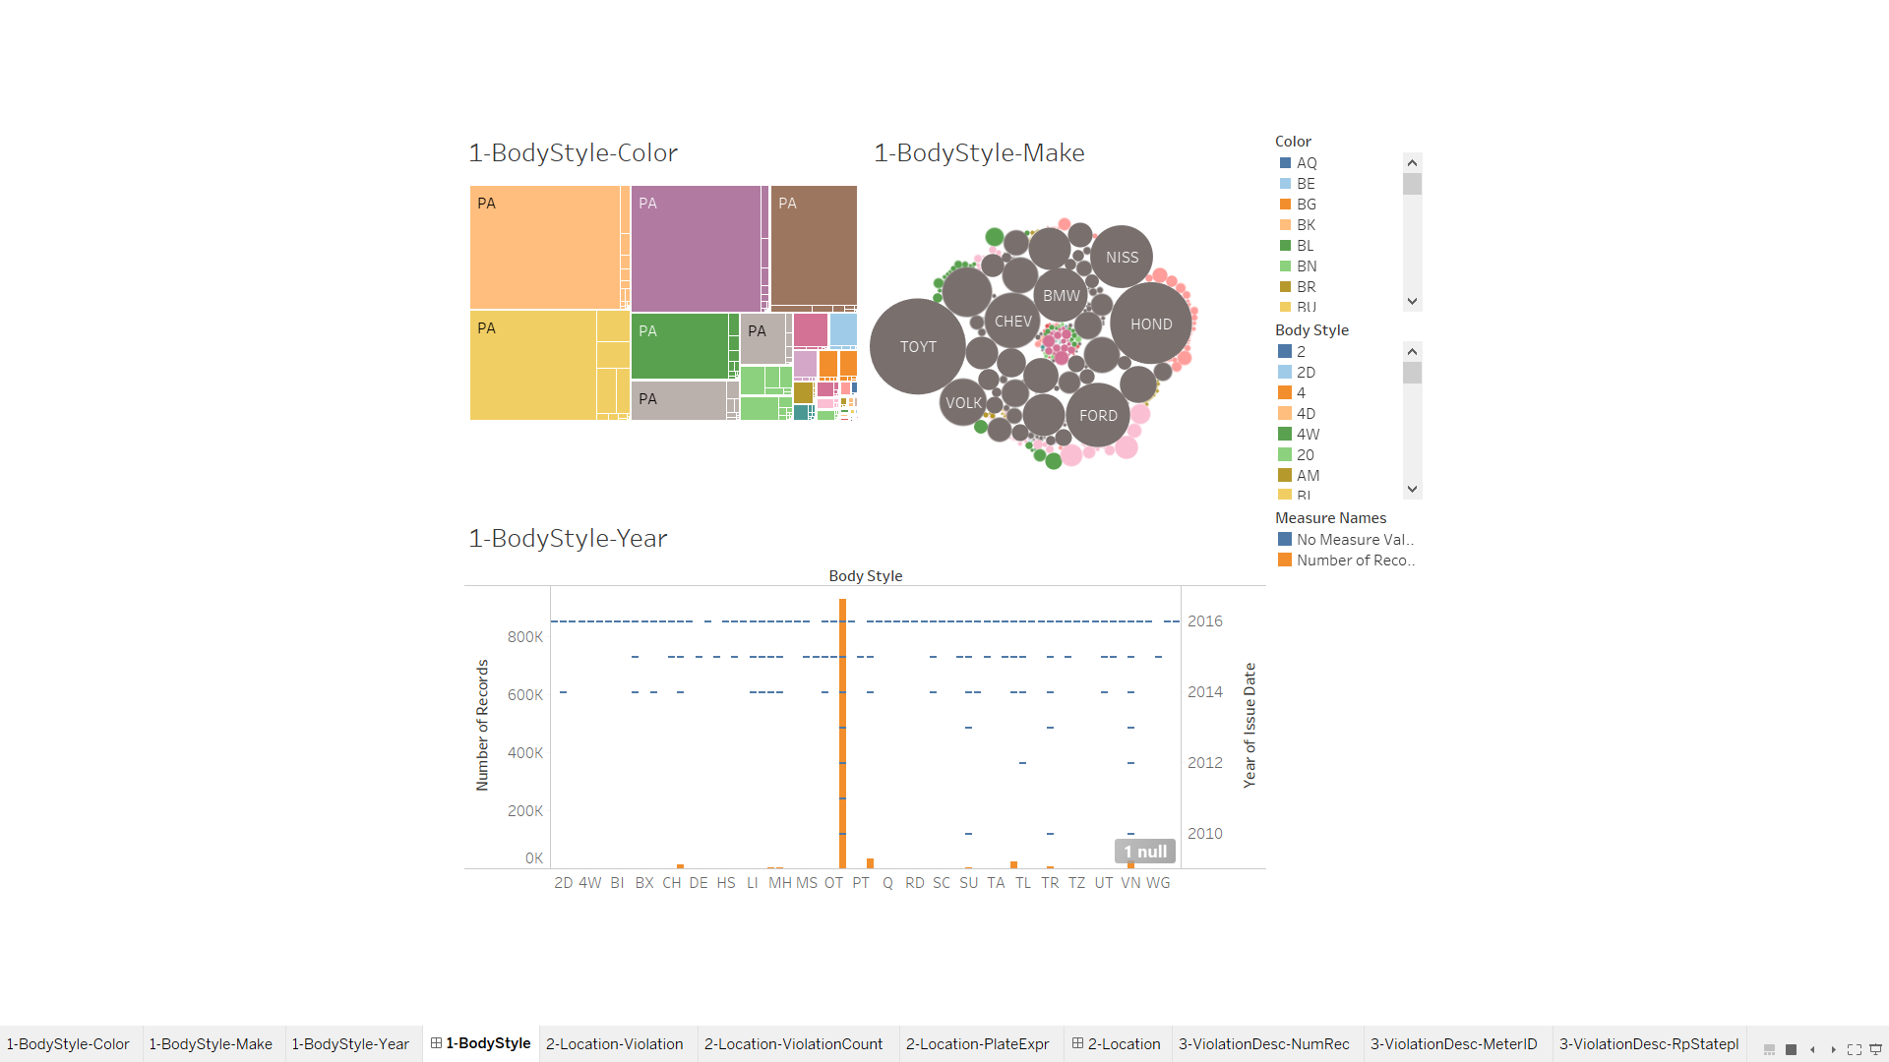

2.1- Location Violation

Sheet shows in which street what type of violation occurred and how many times. By looking this sheet we can distinguish the violation more clearly. We can also filter violation description and location which gives us better perspective to comment on what is wrong.

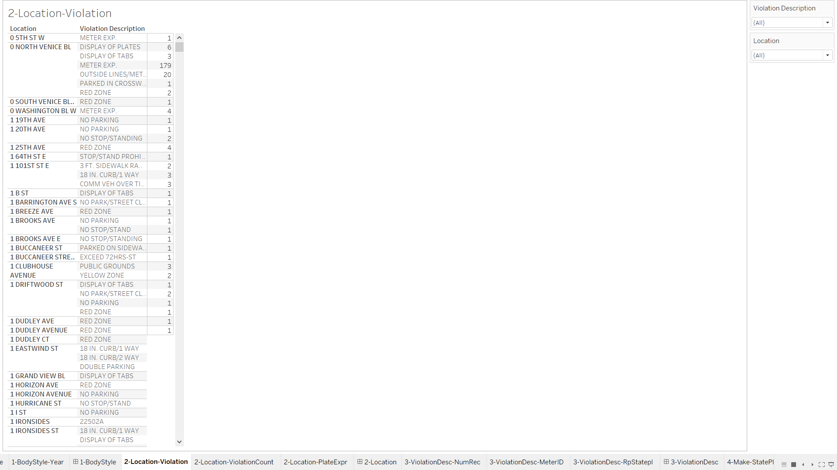

2.2- Location-Violation Count

This sheet gives us the total number of violation occurred in each street, order by highest number to lower as left to right.

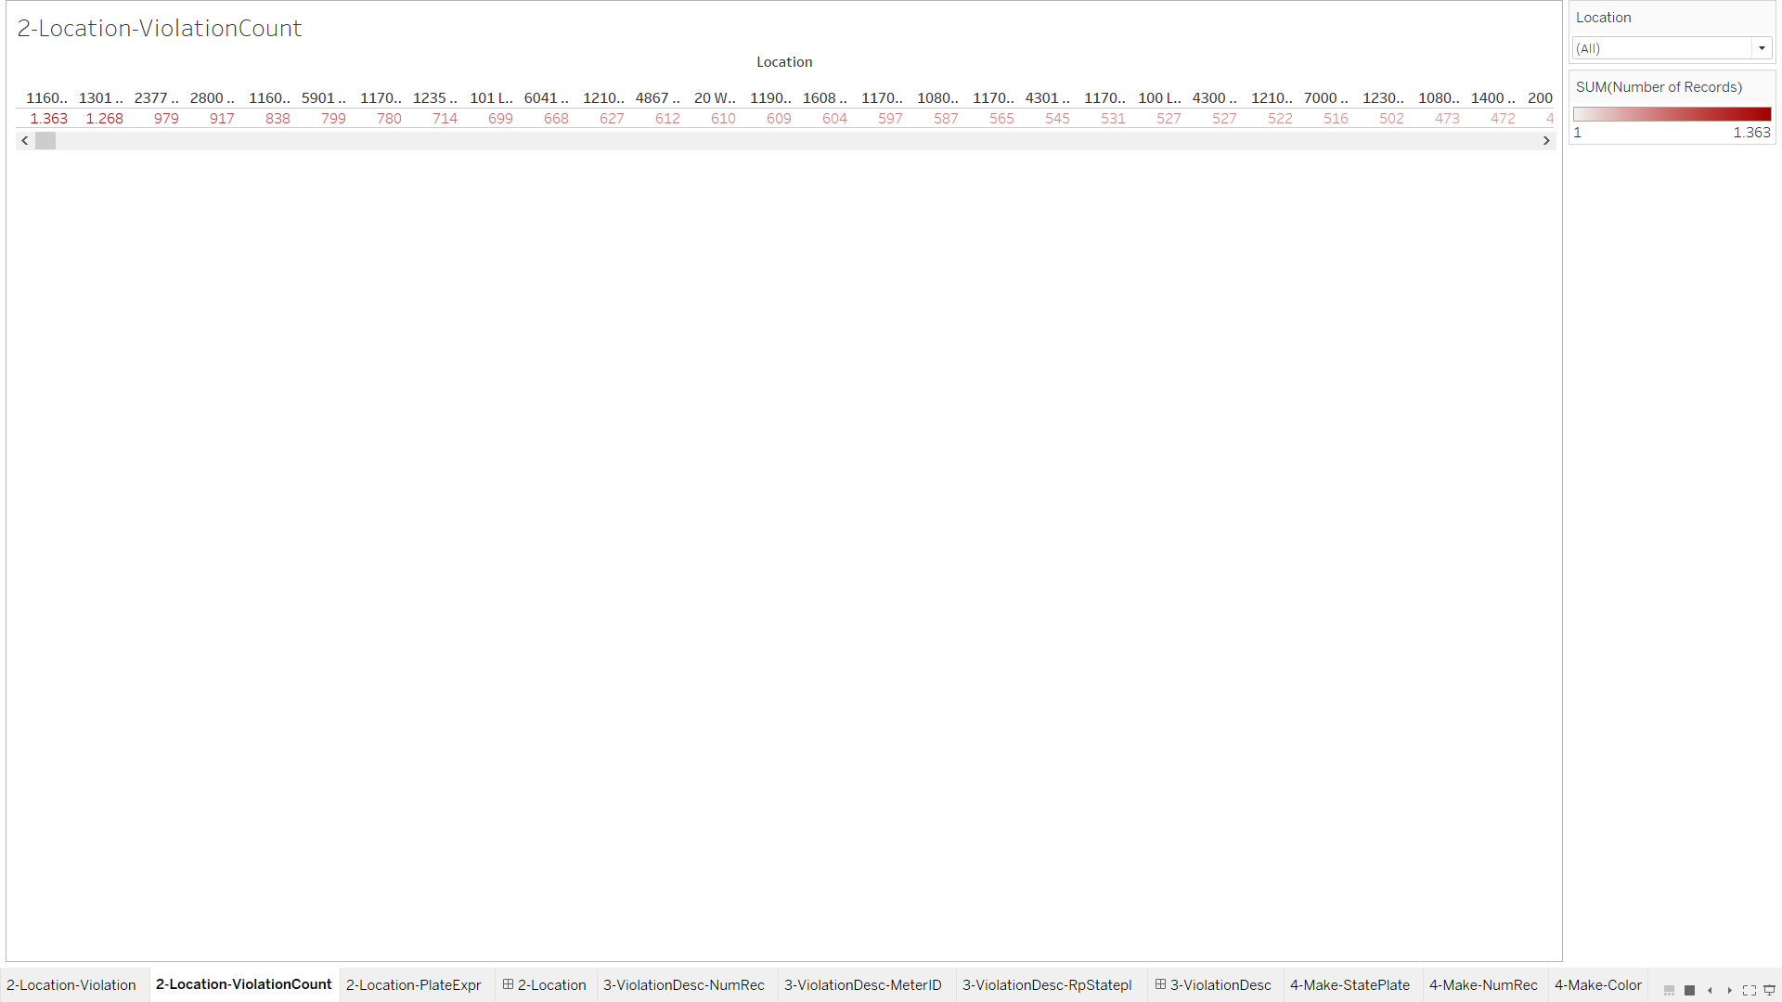

2.3- Location- Plate Expire

In this sheet we can see the expire date of the vehicle plate by grouping these plate with location we can observe if there is relation like when plate expire is close more violations occurring.

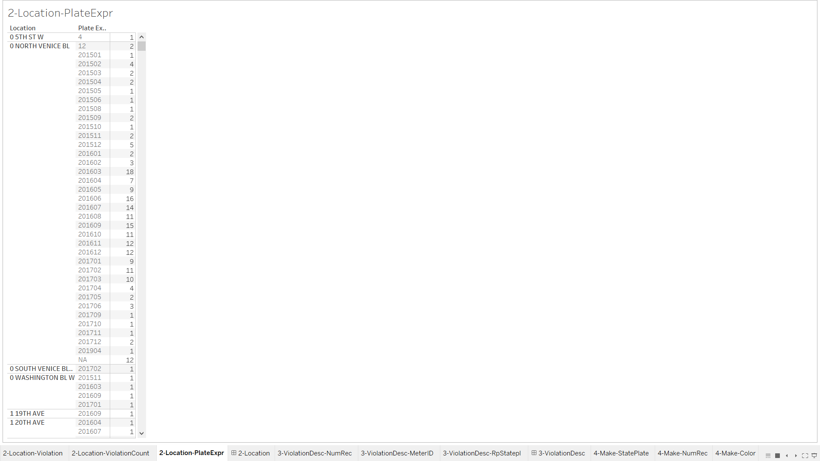

2- Location (Dashboard)

In this dashboard we can see the violation number and what type of violations occurred in specific locations, the dashboard have location filter and also by clicking on sheets type it can also filter in other sheets.

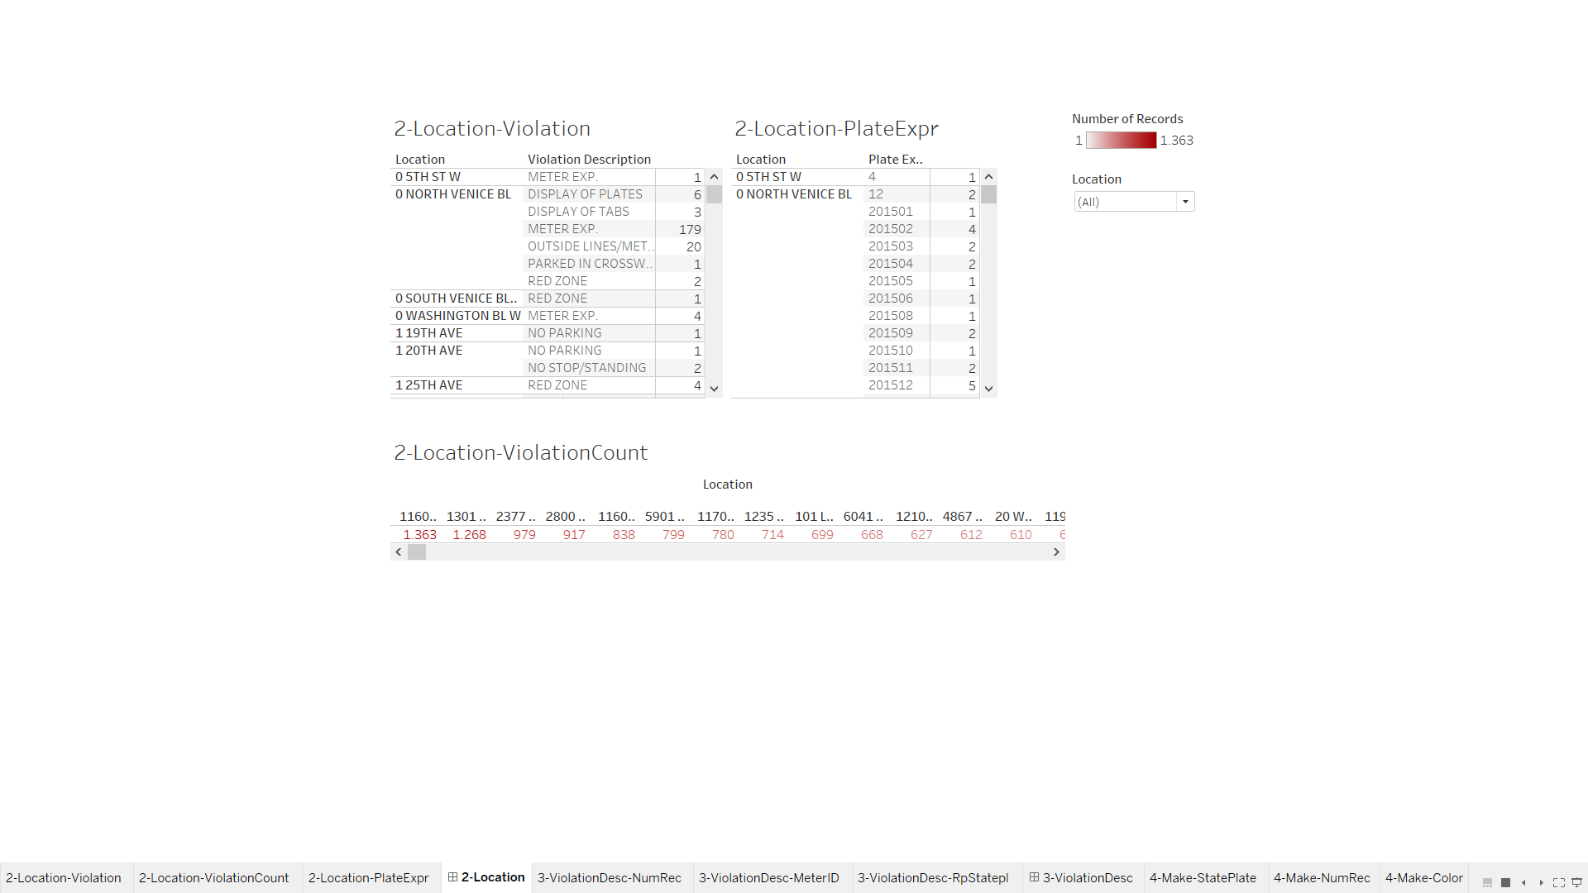

3.1- Violation Description- Number of Records

The graph is ordered by most number of the most violation to less, so we can see the Non Parking is the highest violated rule that shows us in LA parking is a big problem.

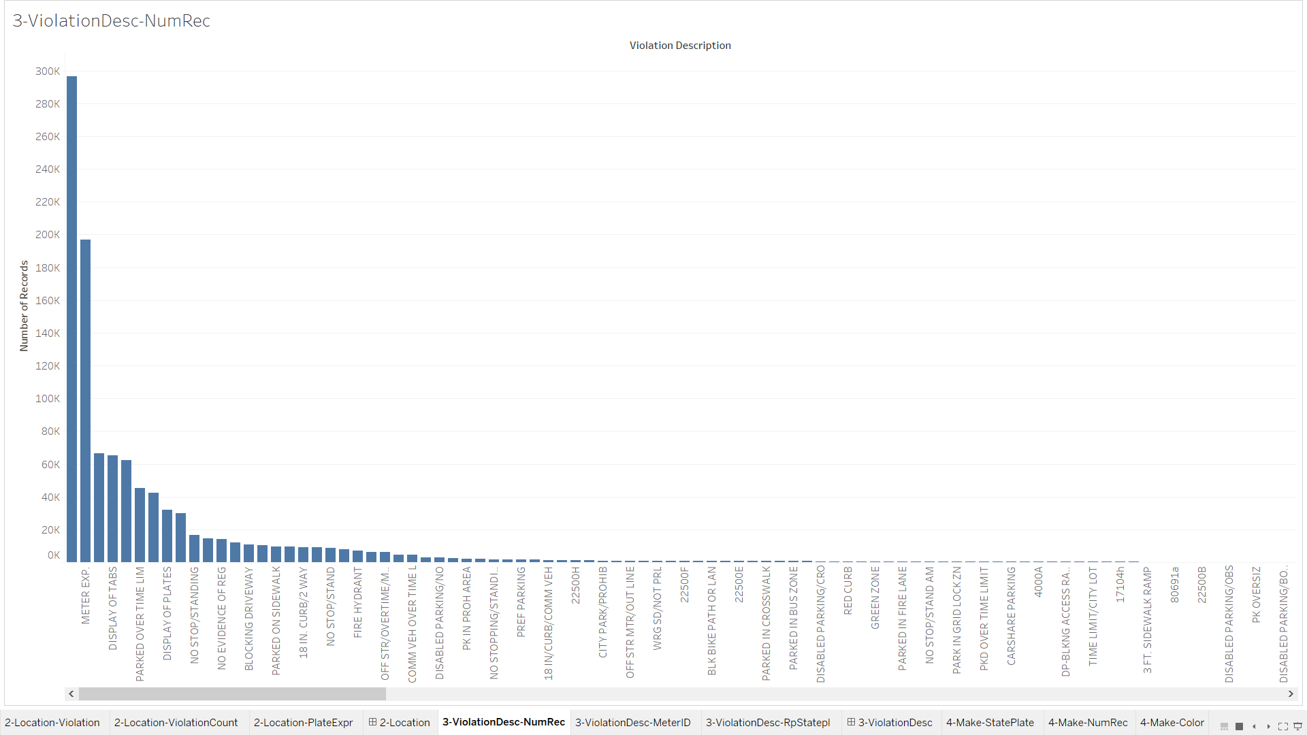

3.2- ViolationDesc- MeterID

This sheet shows us what kind of violation occurred and how many times occurred near this park meter. Most of the violations marked as preferential parking “preferential parking regulations manage the use of on-street parking to assist residents with valid permits and their guests in finding parking near their homes.”

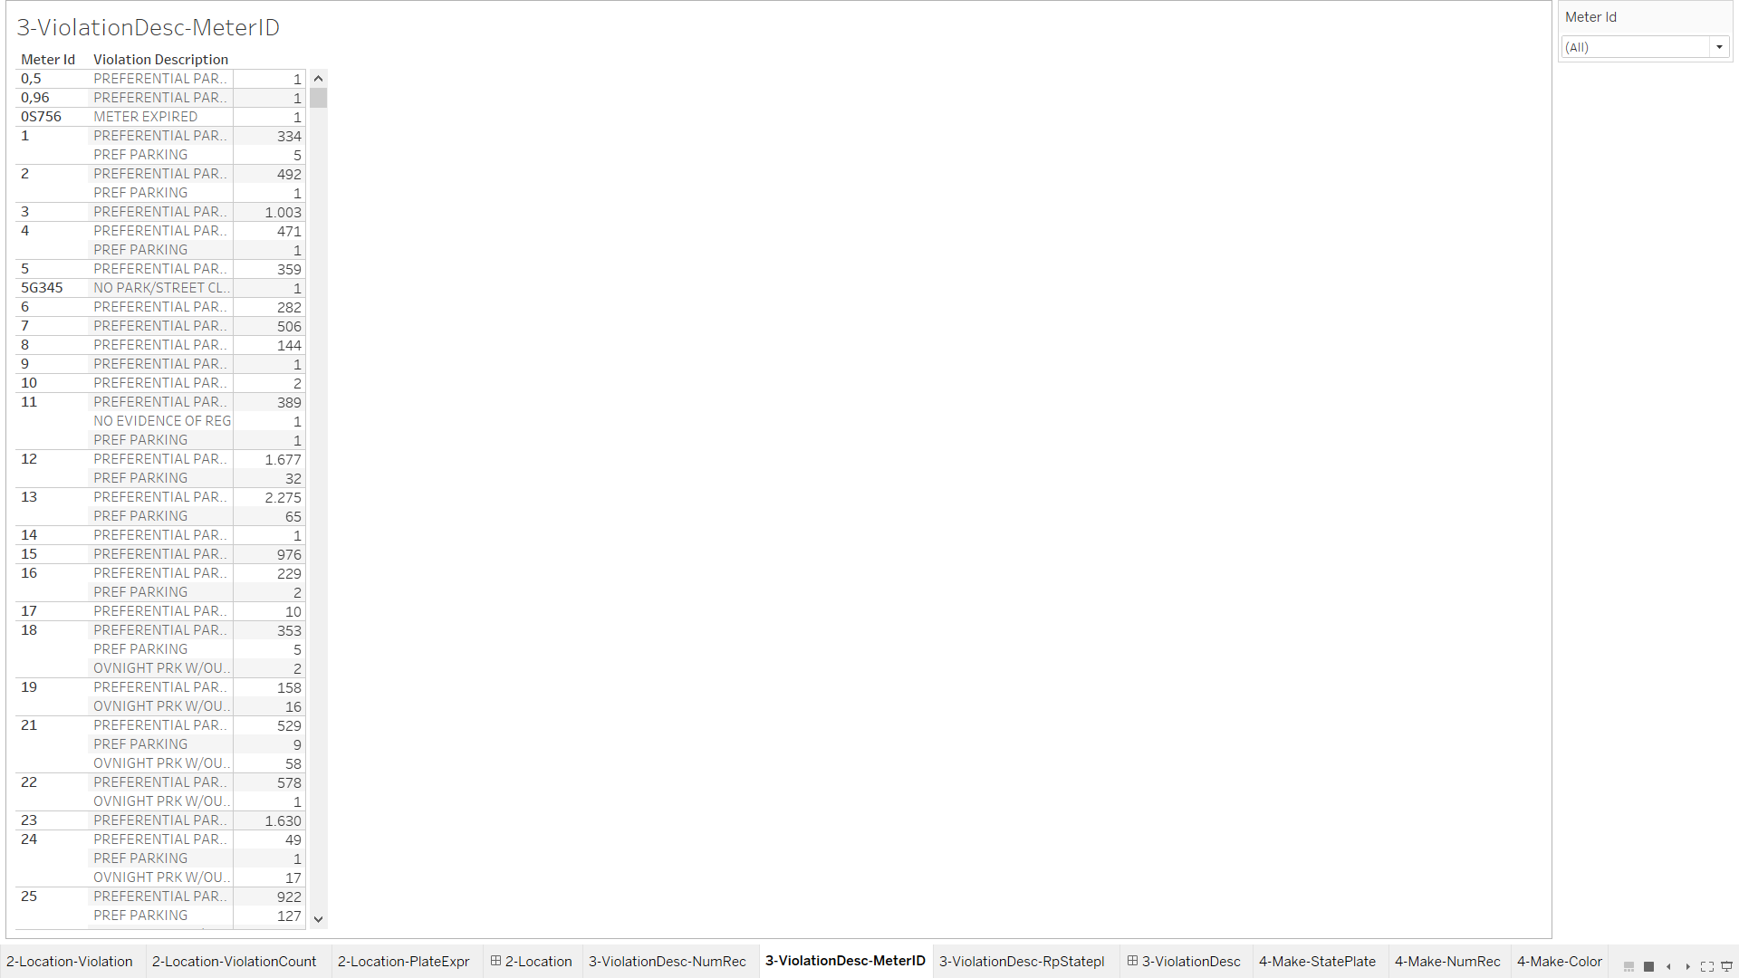

3.3- ViolationDesc- RpStatepl

This sheet shows us which state plate made violations in which street with number of records. By seeing many different types of plate in one street we can assume that there is an hotel or special facility that attracts people from different state to this street.

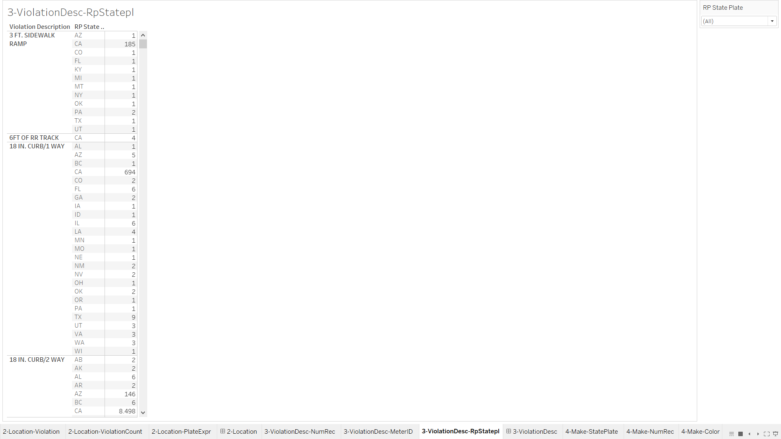

3-ViolationDesc- NumRec(Dashboard)

In this dashboard we can observe what is most violated in parking-citations and which meterId have the most record of that violation. We can also filter it by state plate and location.

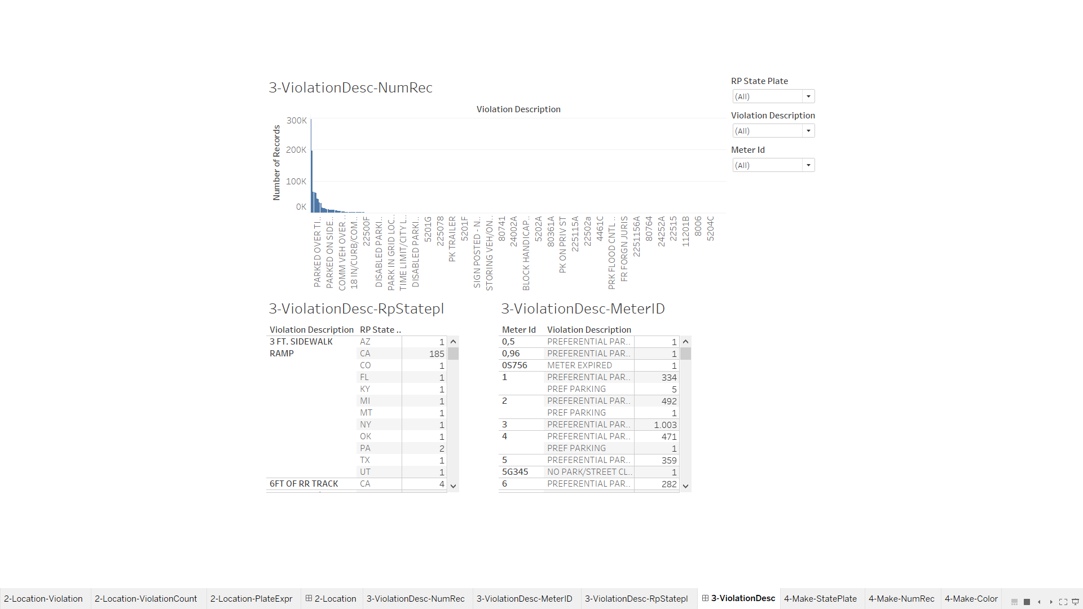

4.1- Make-StatePlate

This sheet show us vehicle make and state plate who violated rules. We can filter which maker is most common in states; which make vehicle results most violation CA plate.

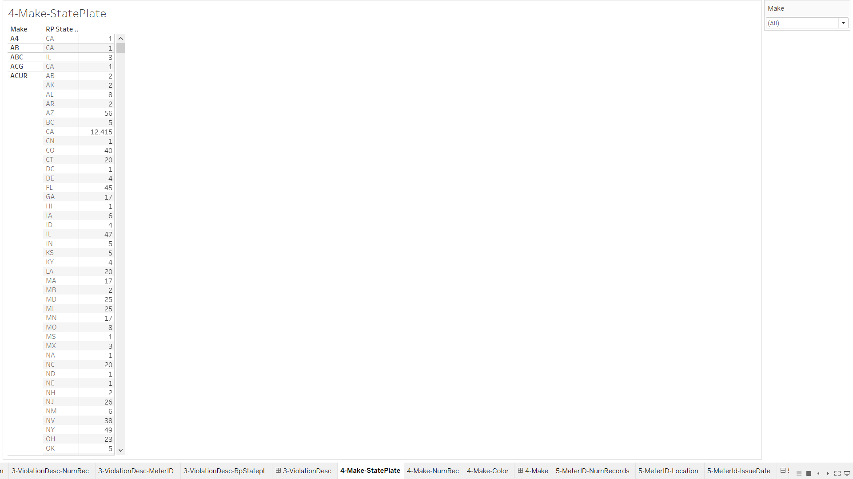

4.2- Make-NumRec

This sheet shows us which make vehicles mostly violates parking-citations.

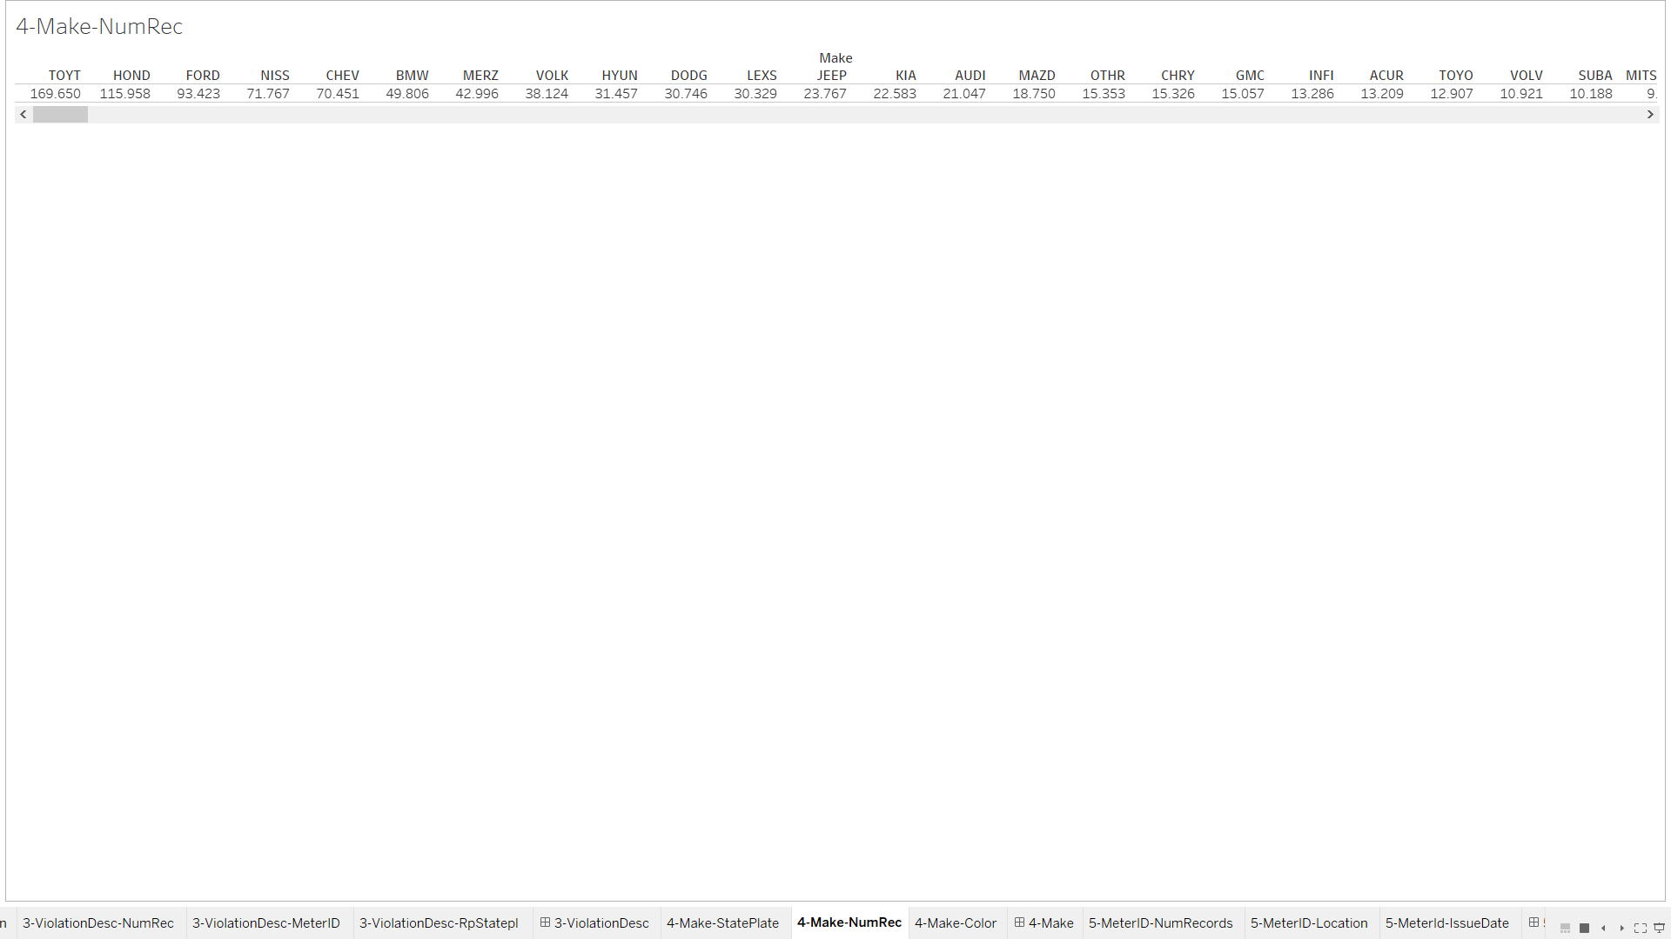

4.3- Make-Color

Sheet shows mainly what type of colored vehicles have the most violation, secondary as in that color which make of car have the most violations. As we can see black color cars have the most violation number, in these black cars Toyota made cars has the highest violation.

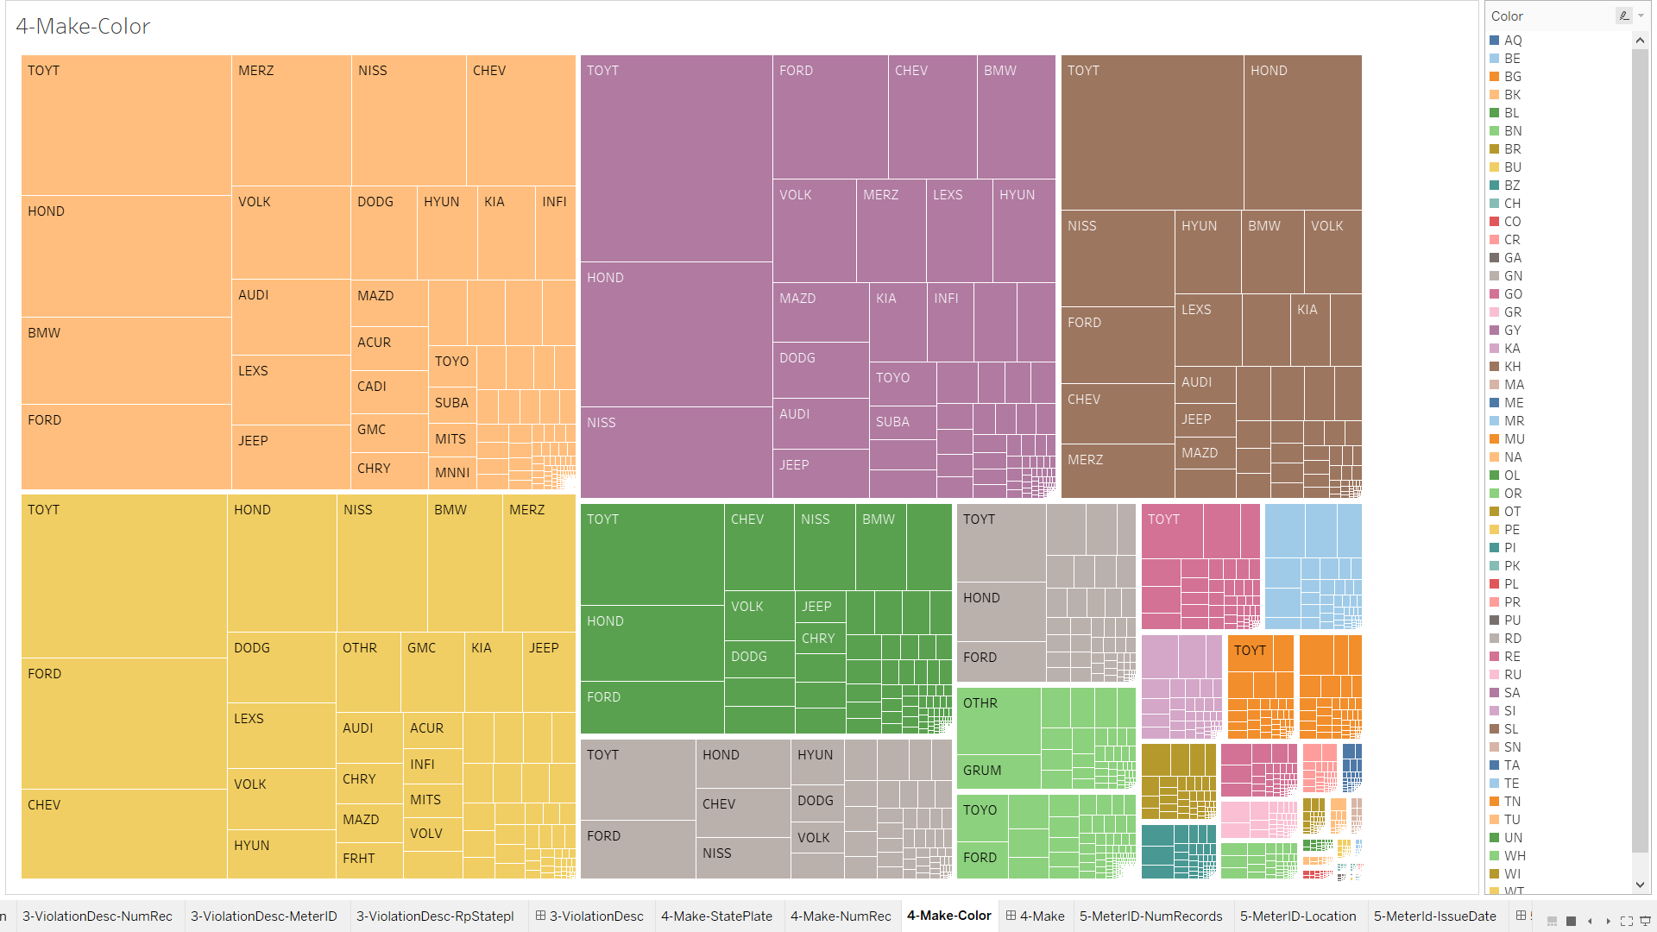

4-Make (Dashboard)

This dashboard mainly focuses on maker of the vehicle, we can analyze the effect of the color in violations and are these related with different state.

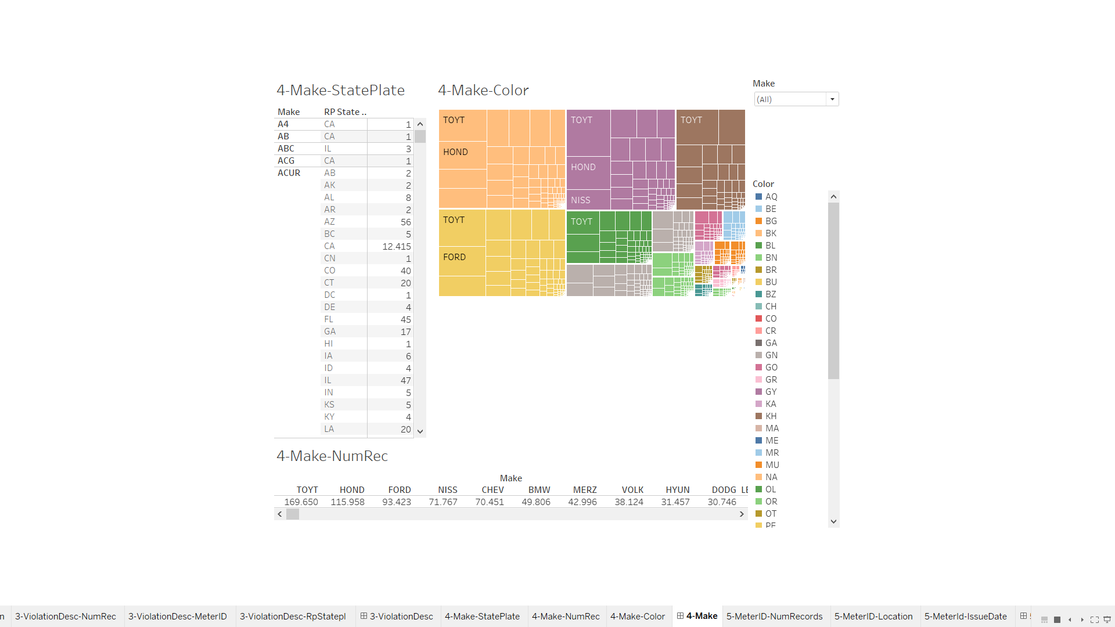

5.1- MeterID- NumRecords

This sheet shows which meters id and their number of records.

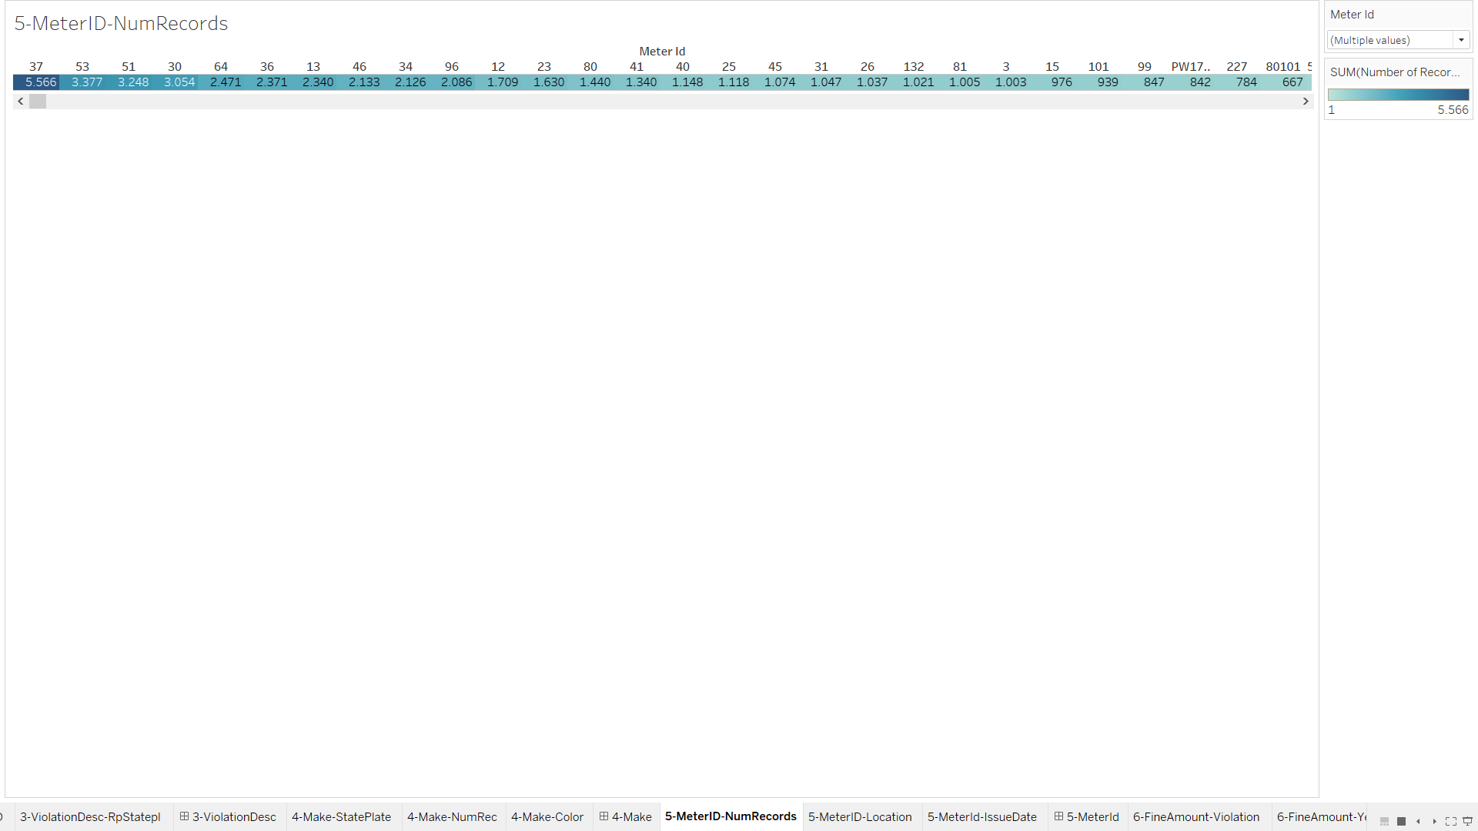

5.2-MeterId- Location

In this sheet we can locate how many meters in that location and how many times it has recorded violations.

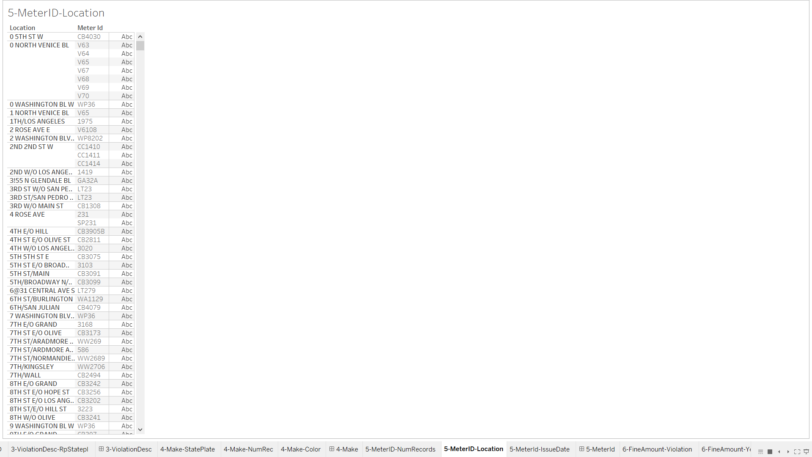

5.3-MeterId-IssueDate

This sheet shows us the increases on parking meter violation over year. As we can see in the beginning of 2014 and 2015 there have been huge number disruptions.

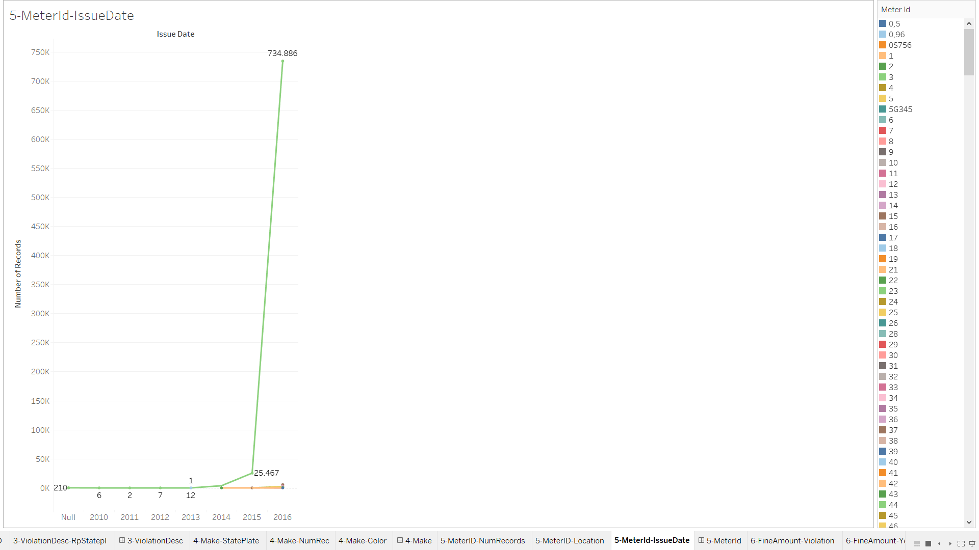

5-MeterID(Dashboard)

In this dashboard we can observe in which location there have been breaking points and total violations that parking-meters recorded.

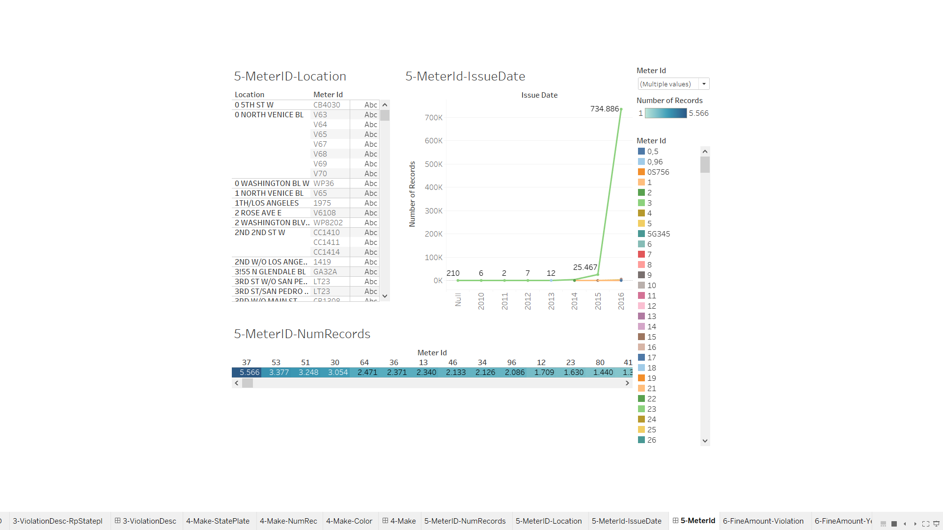

6.1-FineAmount-Violation

This sheet gives us the price of the violation; the violations are sorted to most expensive to the cheapest we can see that 8755** described violation have the most expensive penalty.

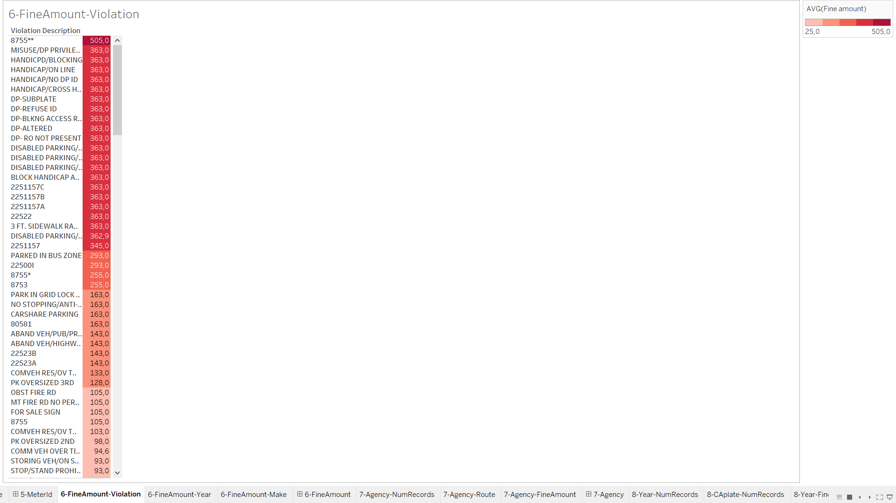

6.2-FineAmount-Year

In this sheet we can observe in time how much money have LA acquired from parking-citations.

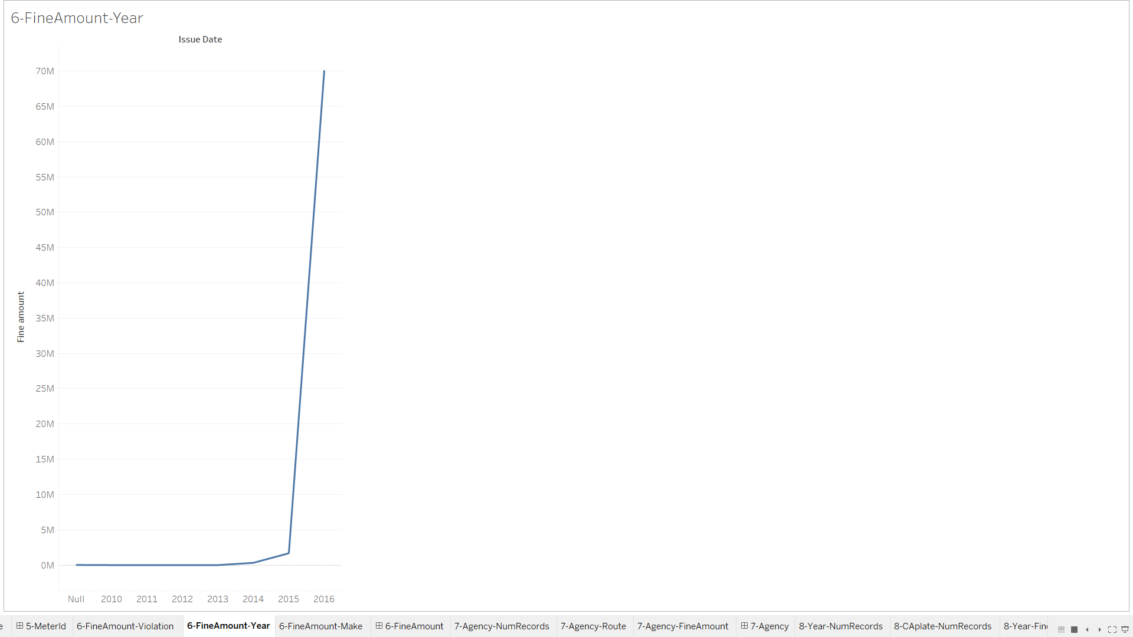

6.3-FineAmount-Make

This sheet shows us total fine amount paid by the make-type vehicles in LA.

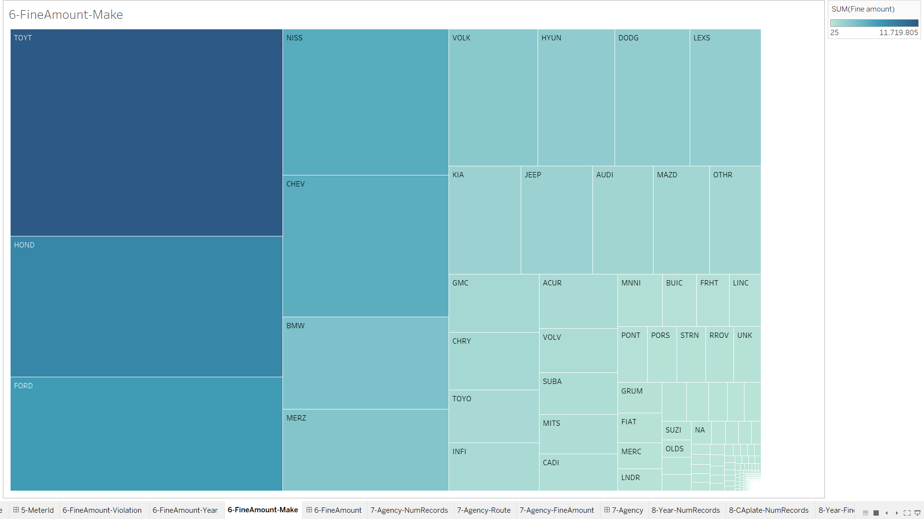

6-FineAmount (Dashboard)

This dashboard gives us information about fine amount of the violations, make relation with total fine amount, In this dashboard we can filter by make and we can also see in year which make type vehicles paid the most fine amount.

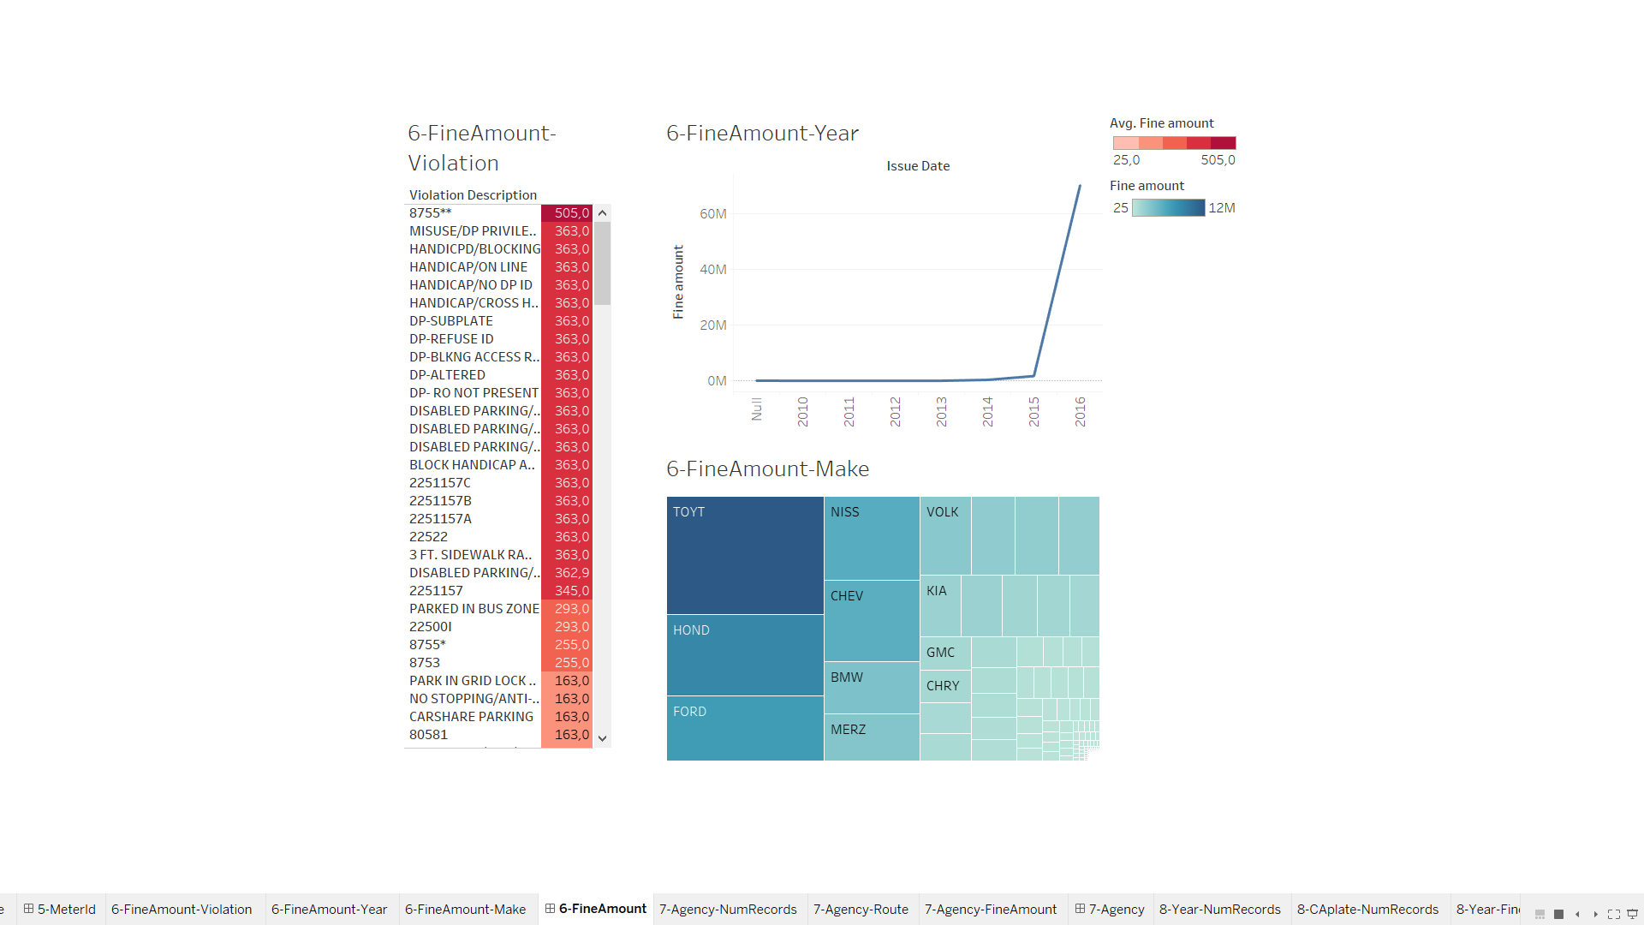

7.1-Agency-NumRecords

This sheet shows us the ids of the agencies and their record numbers, In this sheet we can observe that most of the agencies records are smaller than 20k and 51agency have the most record.

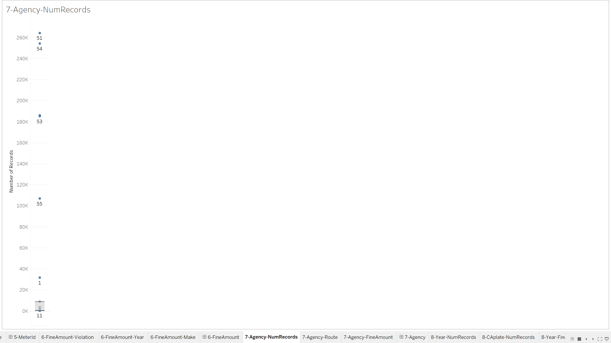

7.2-Agency-Route

In this sheet we can observe the route of the agency and which route they have recorded the most.

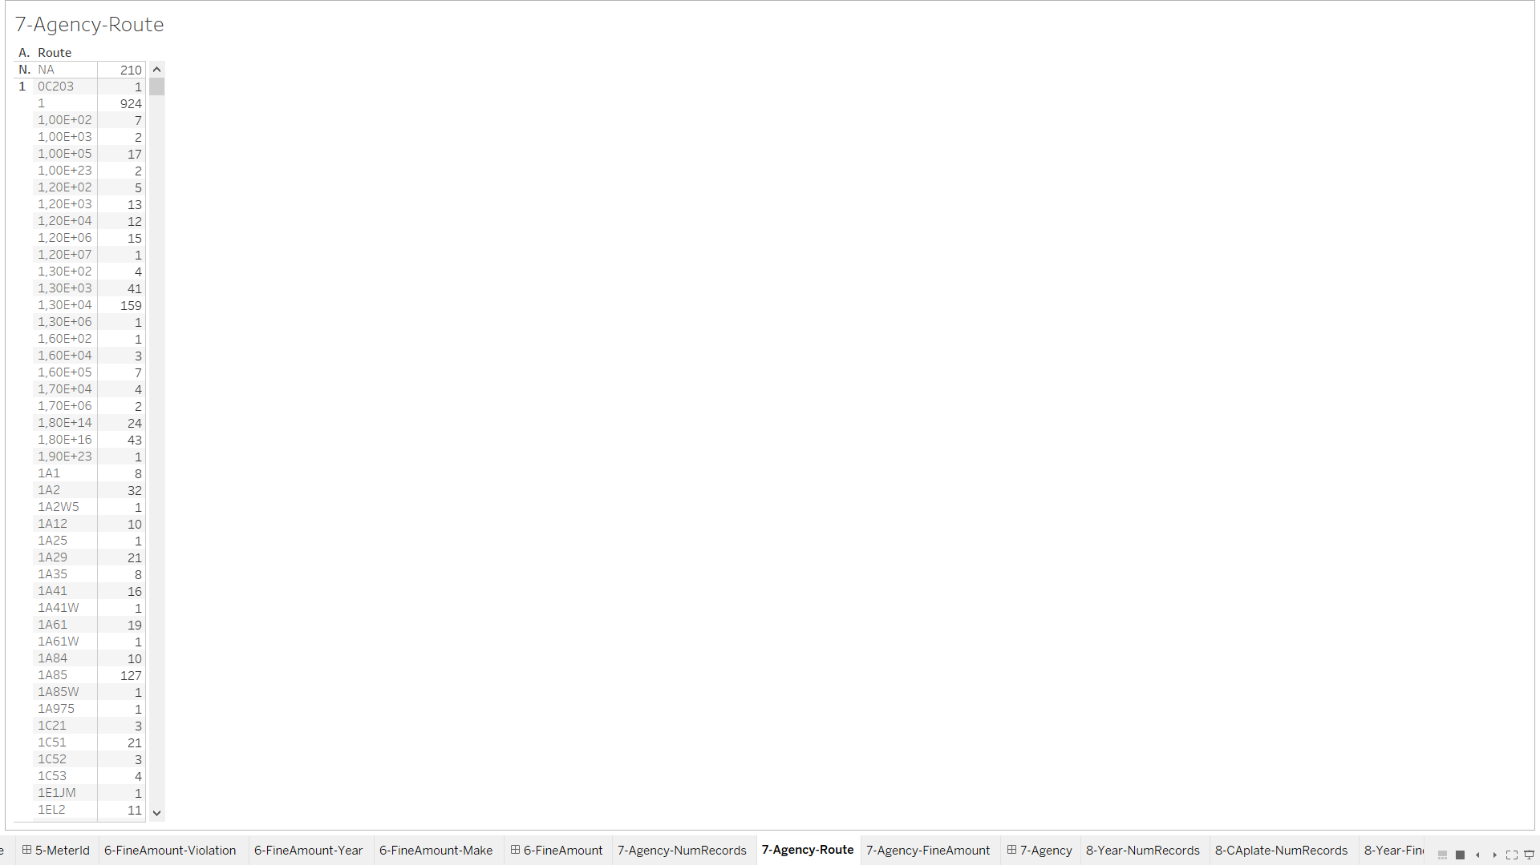

7.3- Agency-FineAmount

In this sheet the sizes of agencies gives us the number of record they have while color shows us the average fine amount they recorded. While agency 56 have more records than agency 55 the average fine of the violation recorded is higher.

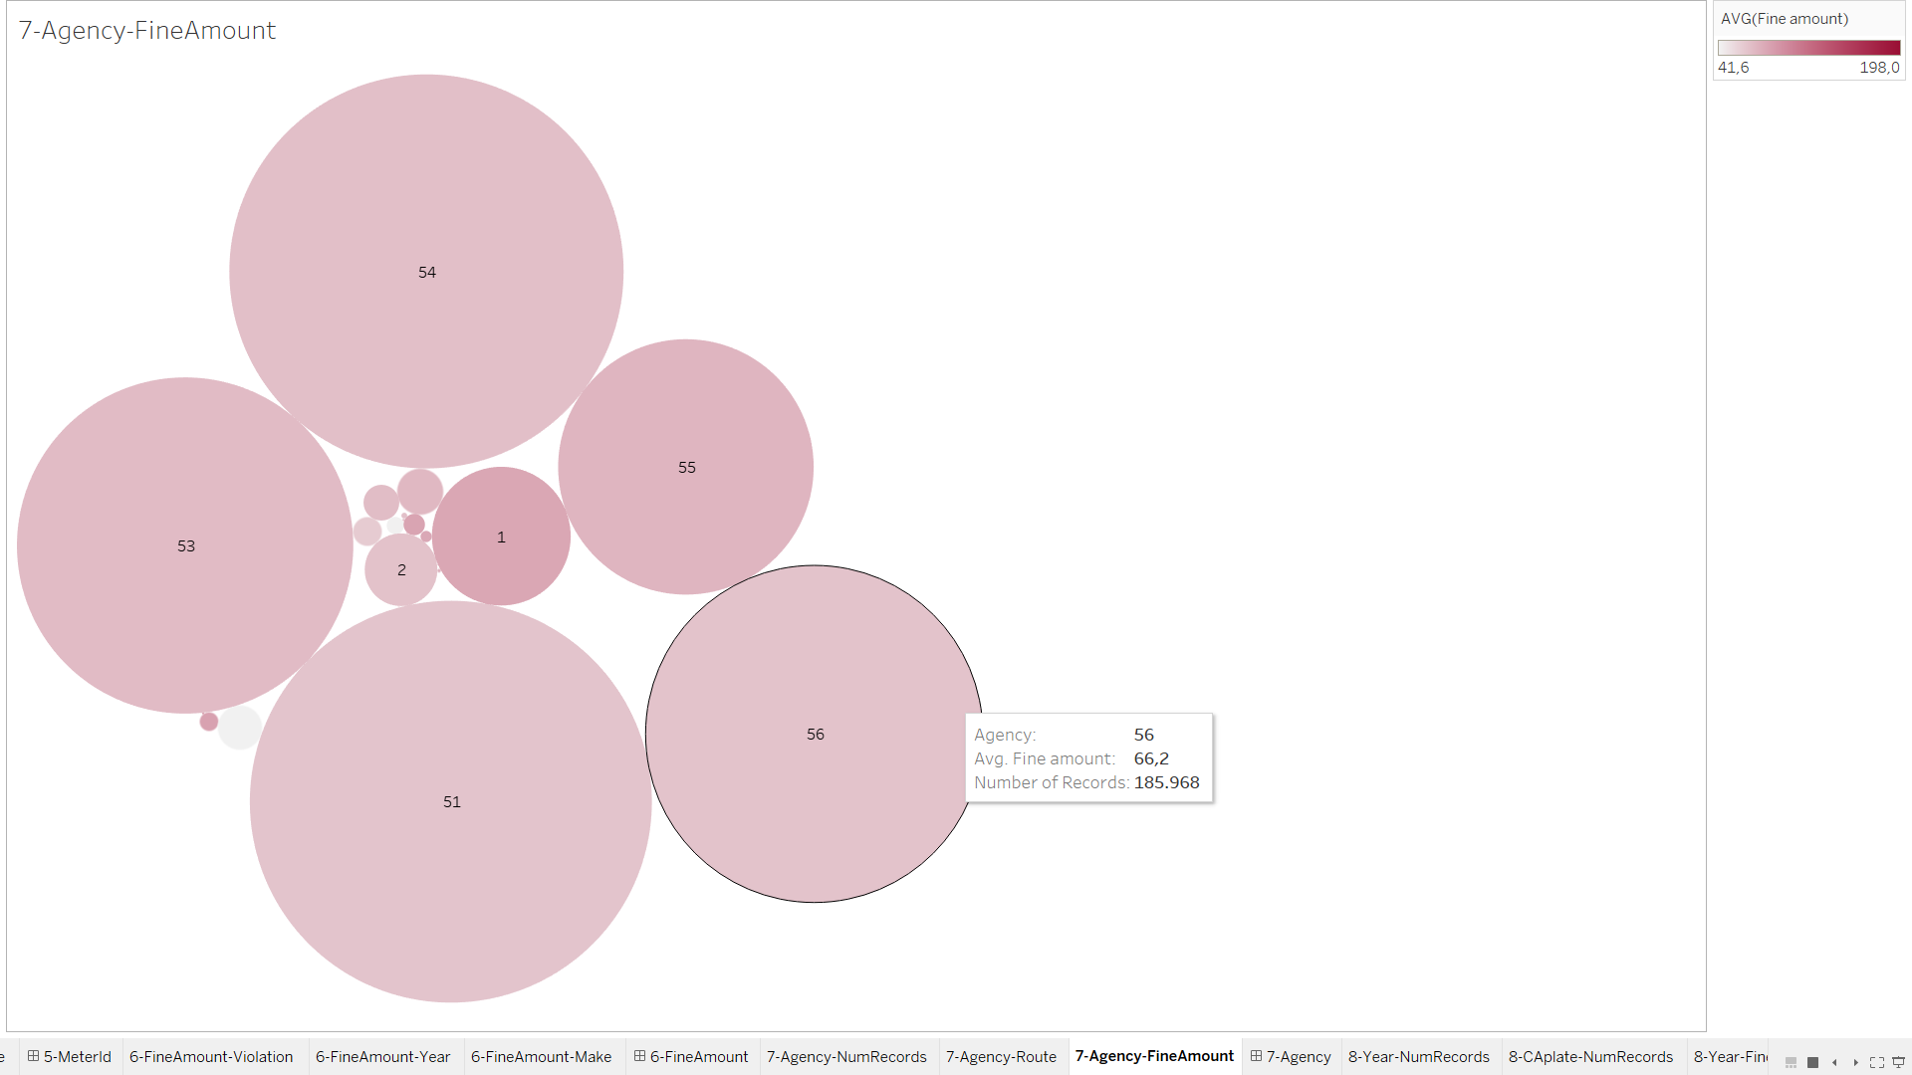

7-Agency (Dashboard)

In this dashboard we can analyze that while some agency have higher record their record doesn’t have remarkable violations like generally simple violations, we can filter the route and agency to decide if there can be potential incident.

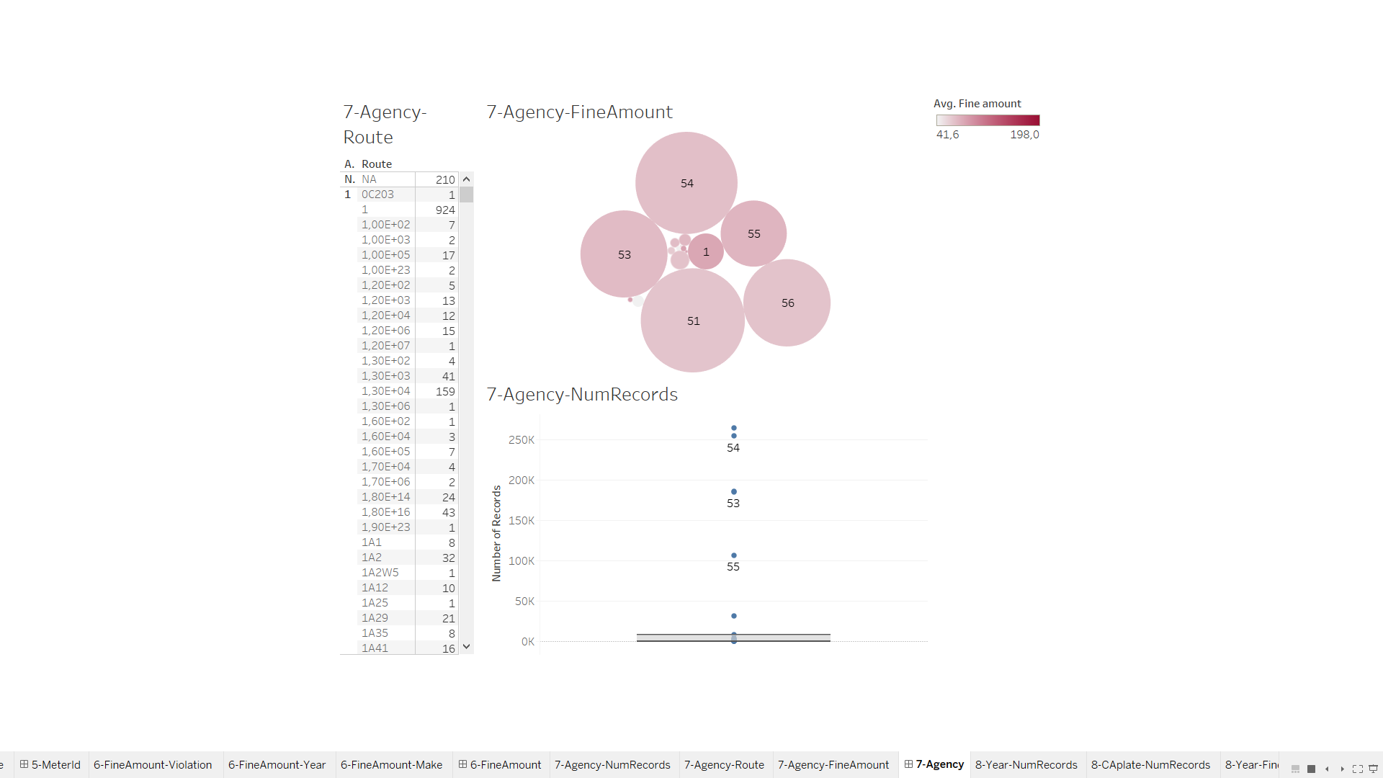

8.1- Year-NumRecords

Sheet gives us record number in time.

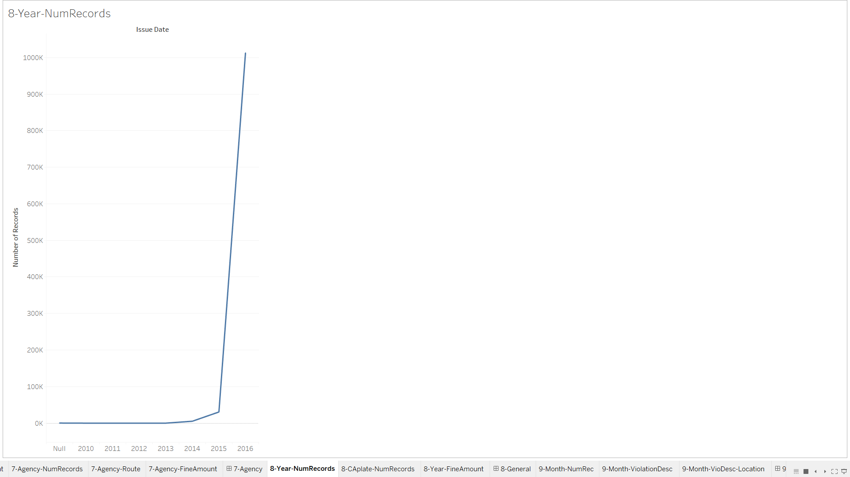

8.2- CAPlate-NumRecords

We can observe the number of violations occurred by CA plate vehicles and non-CA plate vehicles.

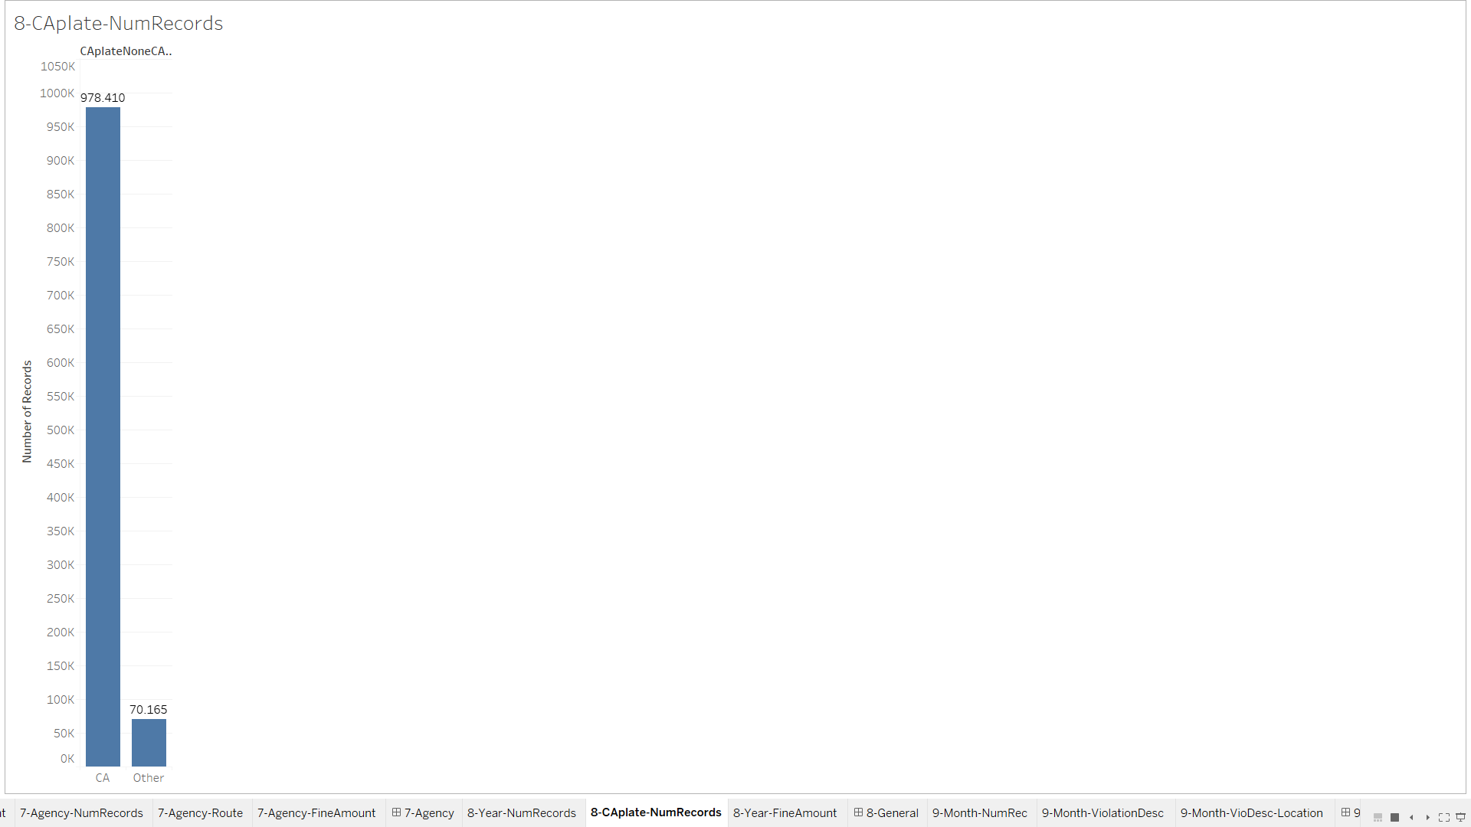

8.3-Year-FineAmount

This sheet shows us changes of fine over year.

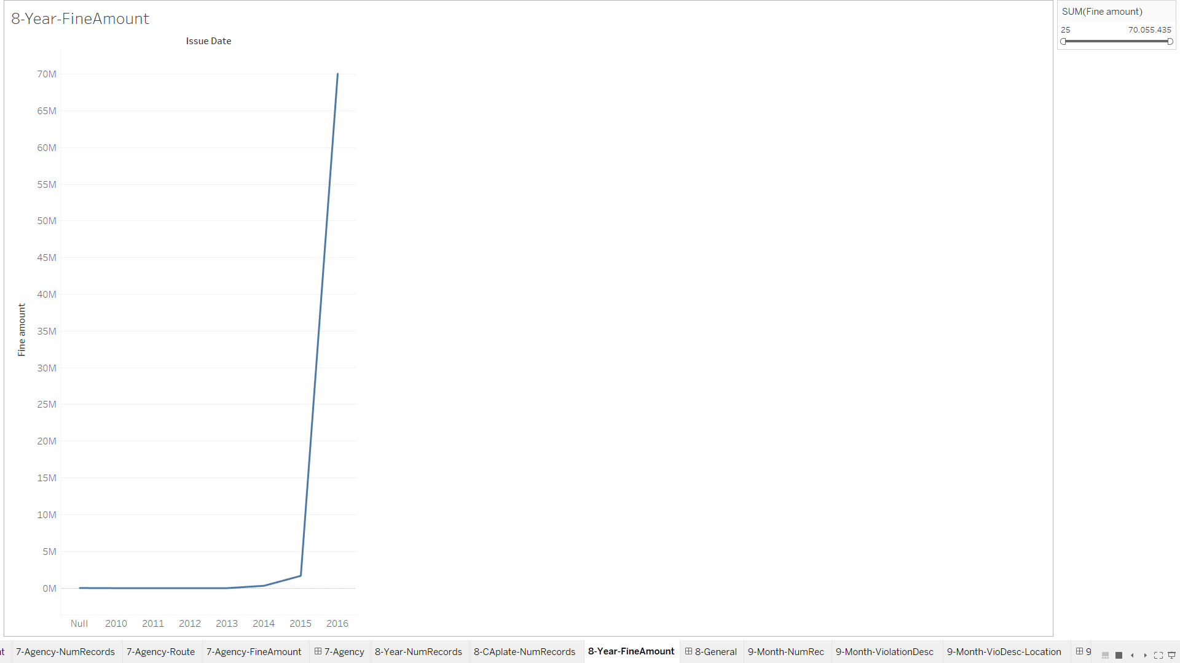

8-General(Dashboard)

In this Dashboard we can gain an general idea about violation different between CA plated vehicles and non-CA plate vehicles.

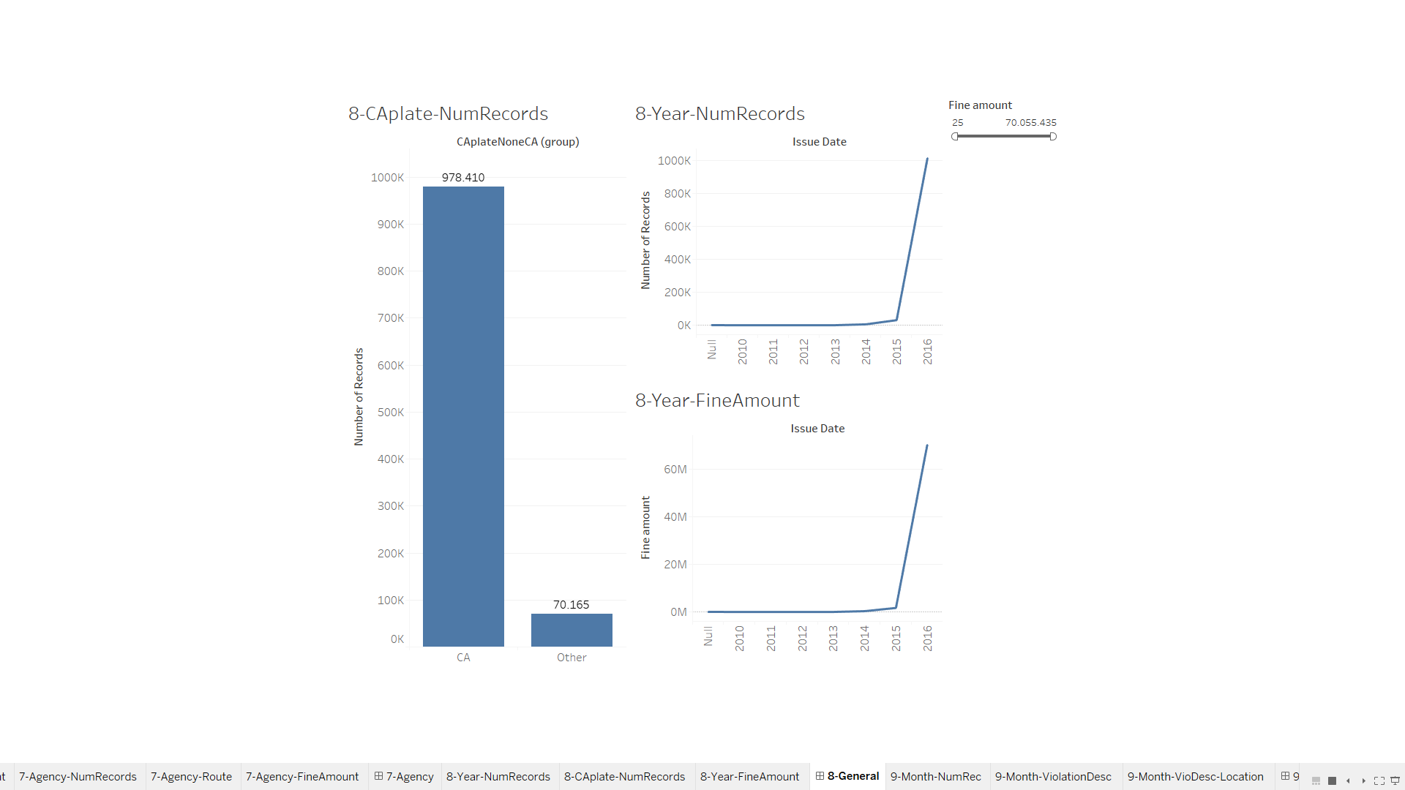

9.1- Month-NumRec

After achieving general idea and understanding the relations between attributes from pervious analysis, we have observing monthly changes in specific years. So we can gain an insight about if the violation have relation between session.

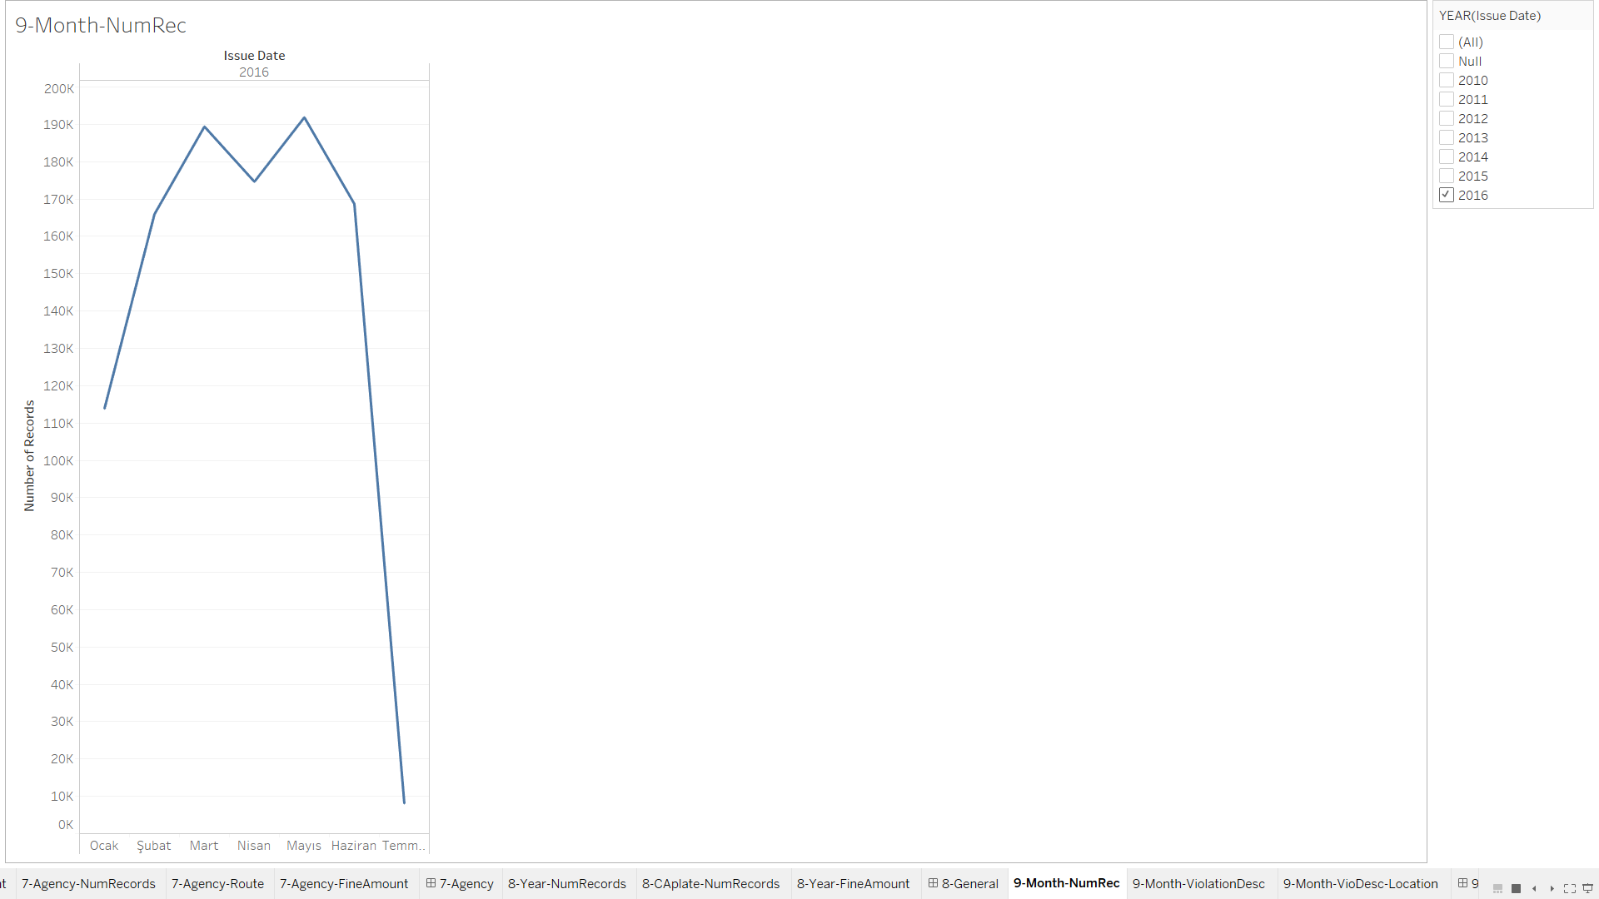

9.2-Month-ViolationDesc

Sheet shows us number of violations in months.

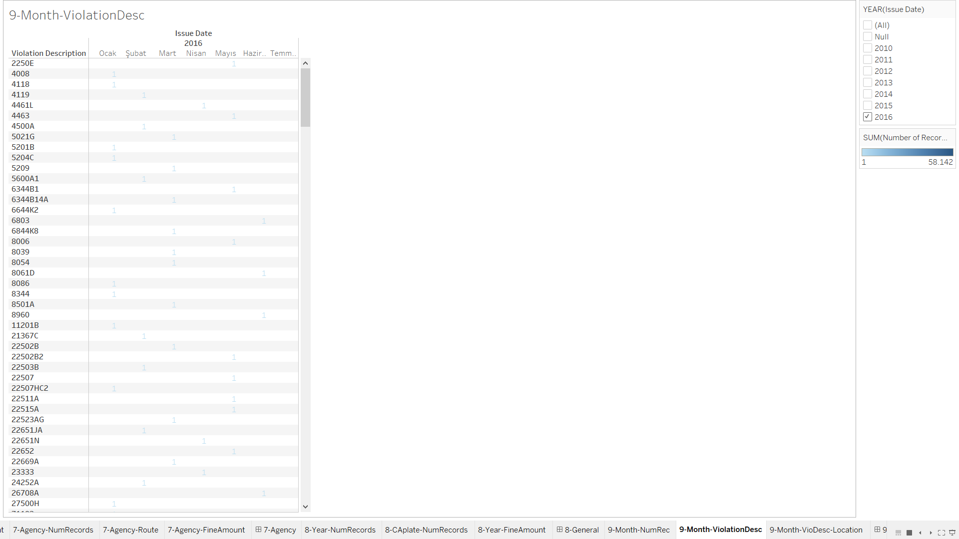

9.3- Month-VioDesc-Location

This sheet allows us to observe violations in locations over month and we by filtering over year we see the violation increases in different year.

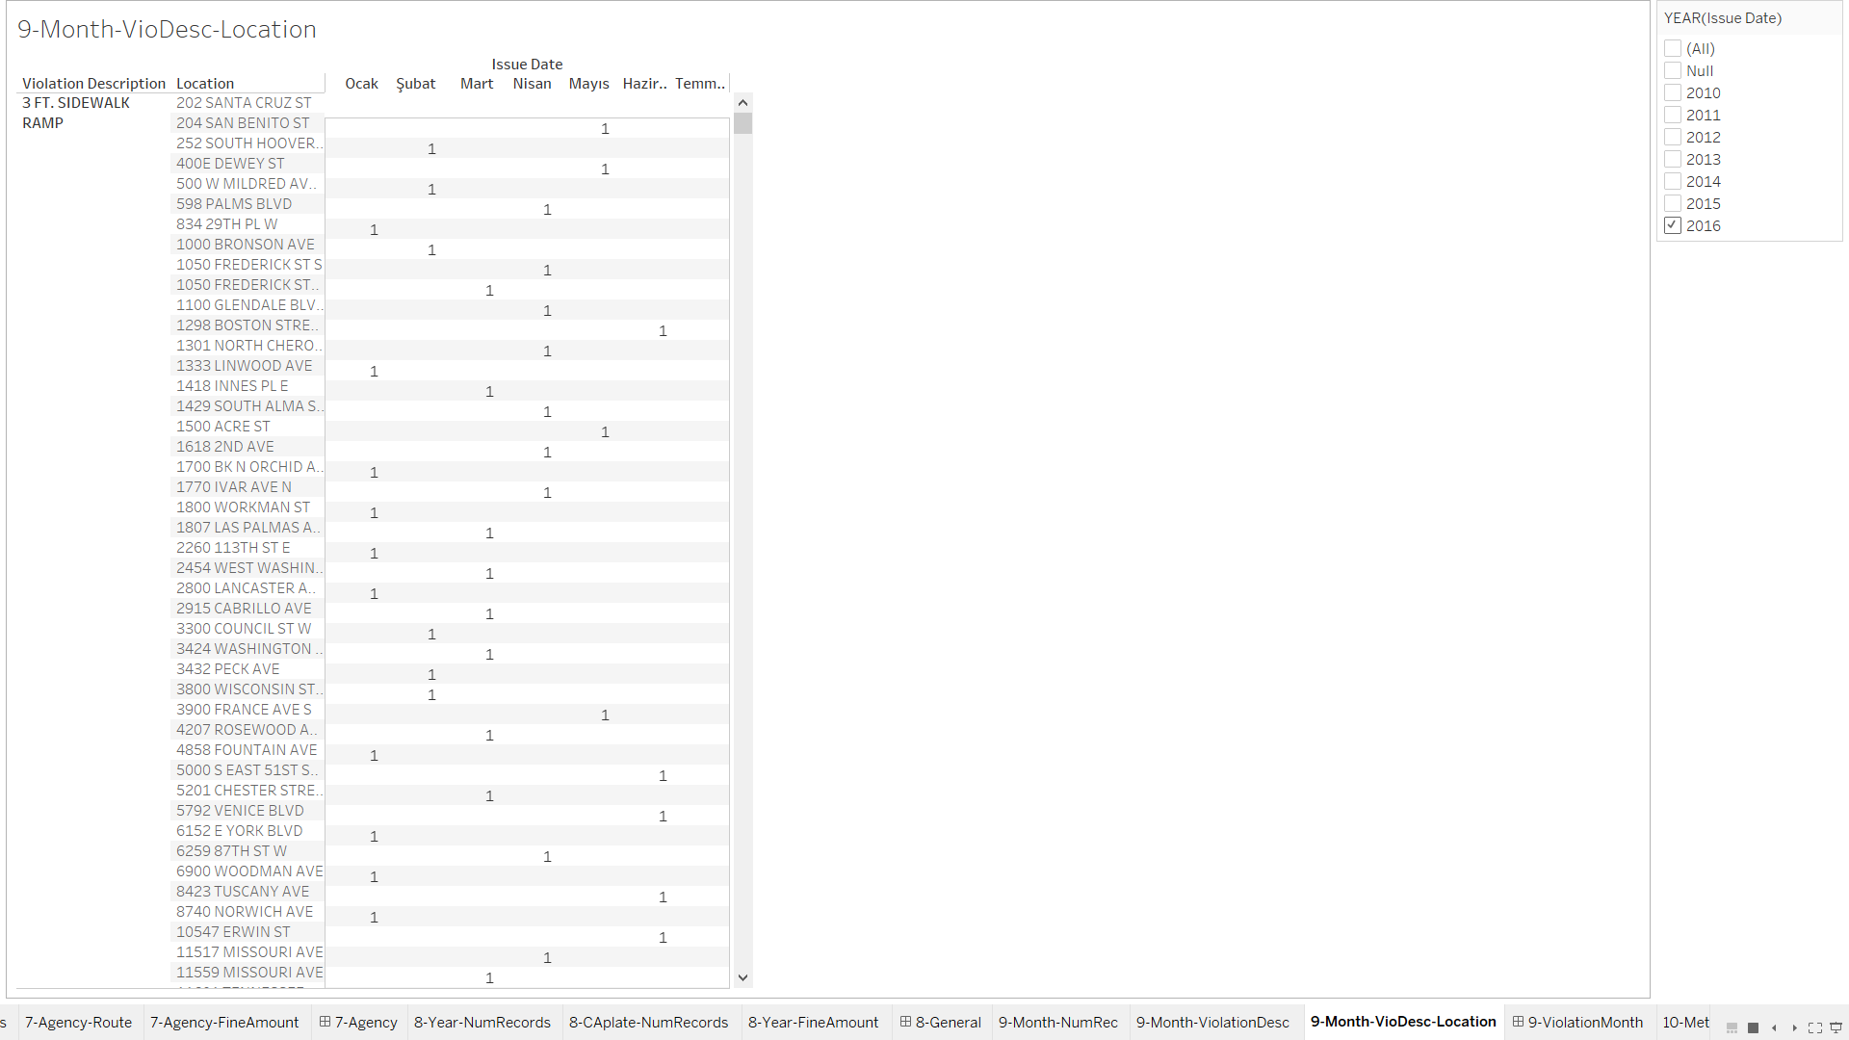

9-ViolationMonth(Dashboard)

In this dashboard all sheets are linked with each other so by focusing on the month we can observe the changes in violations and their locational relations.

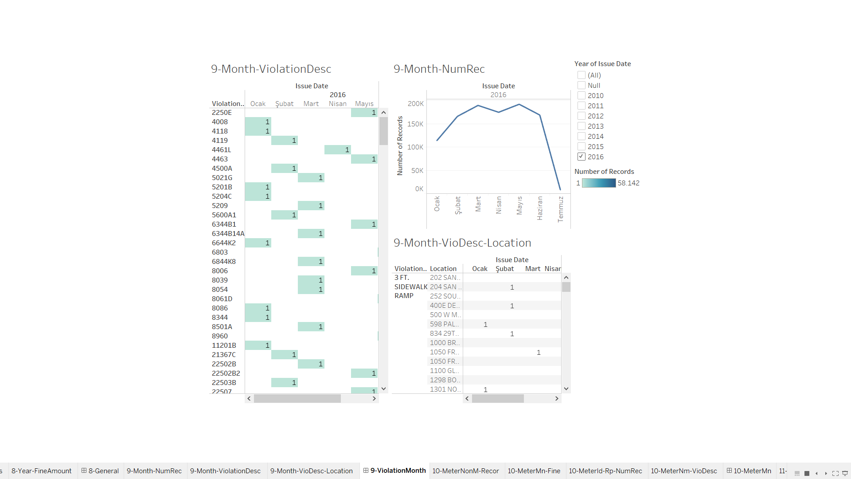

10.1-MeterNonM-Record

Number of records recorded by parking-meter.

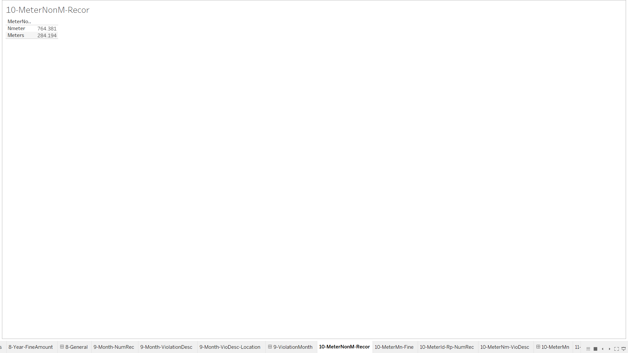

10.2-MetetMn-Fine

The fine amount acquired from parking meters and none.

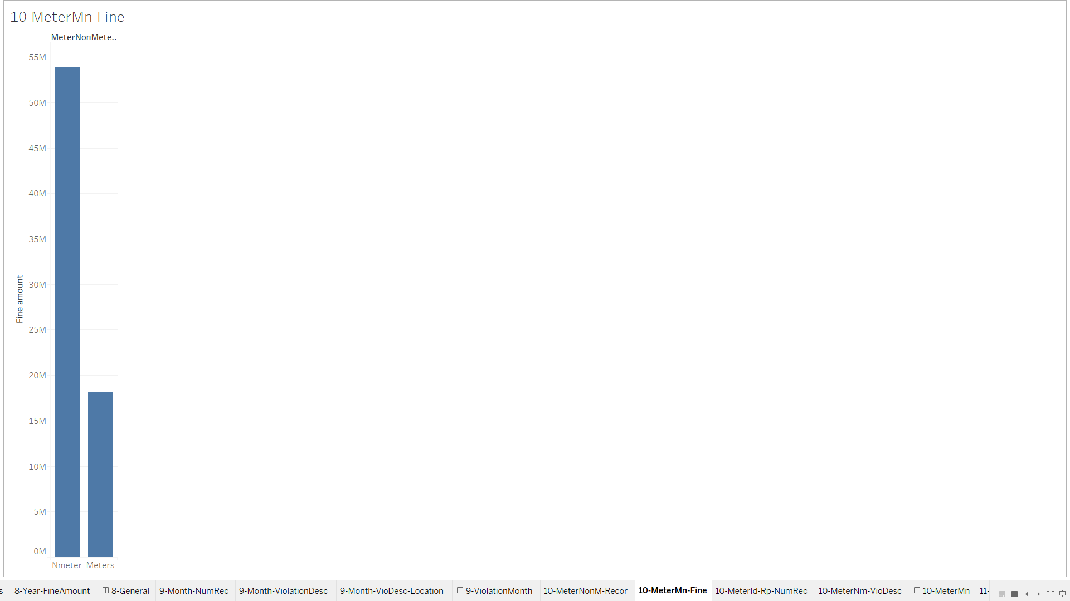

10.3-MeterID-Rp-NumRec

In this sheets we can see that the record difference between meter and None-meter, we can observe that CA plate record between other plate is drastically different between park-meter and None-park-meter.

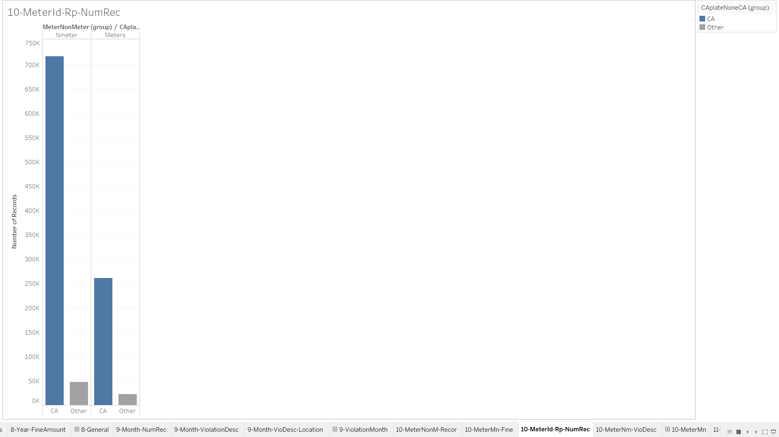

10.4-MeterNm-VioDesc

Shows what type of violation recorded in park-meter, none and number of records. We can filter the group of the meter.

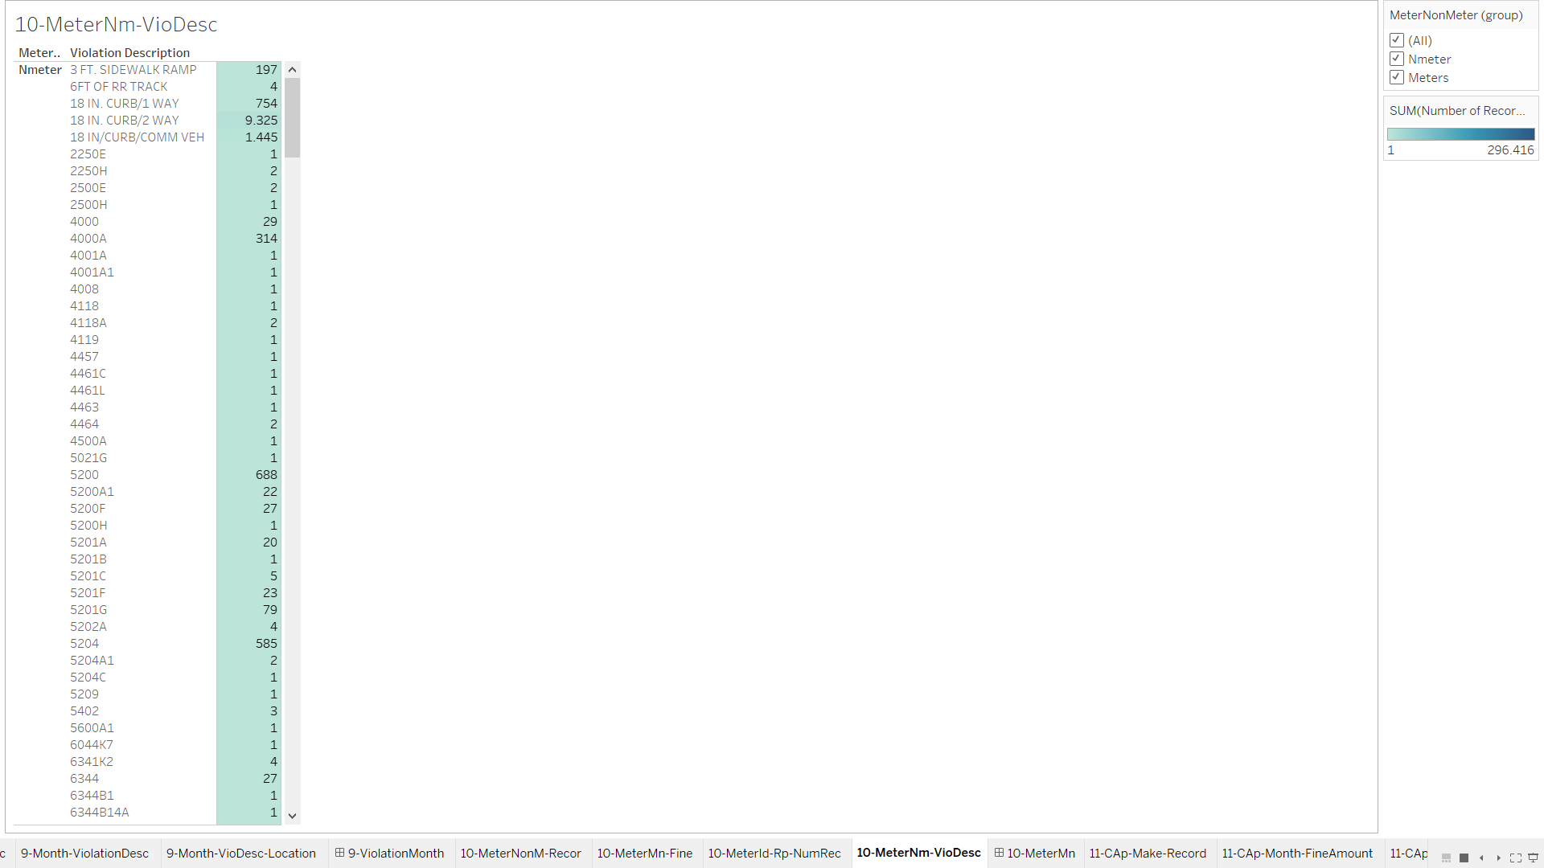

10-MeterNM(Dashboard)

In this dashboard the sheets are linked to each other we can observe the fine amount differences between meters-type, and we can filter by plate type, violation description.

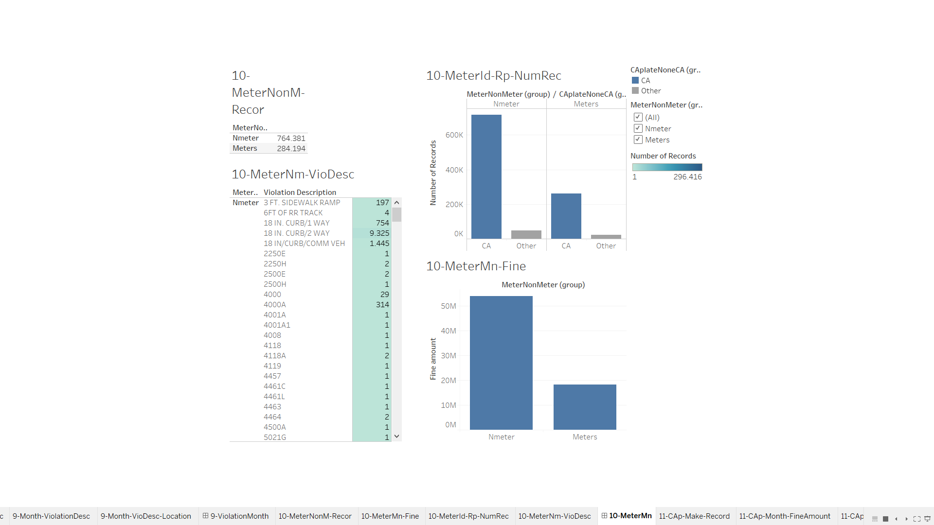

11.1-Cap-Make-Record

Gives information about CA plated cars maker, we can observe that most common car in CA plate is “Toyota 169.650”.

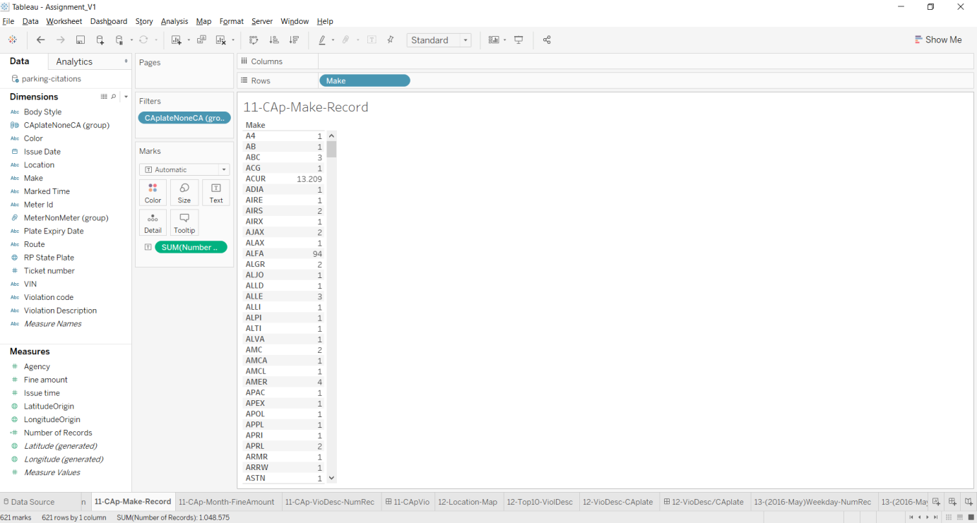

11.2-CAp-Month-FineAmount

This sheet shows us in 2016-June CA plate vehicles have paid the highest fine amount in this year

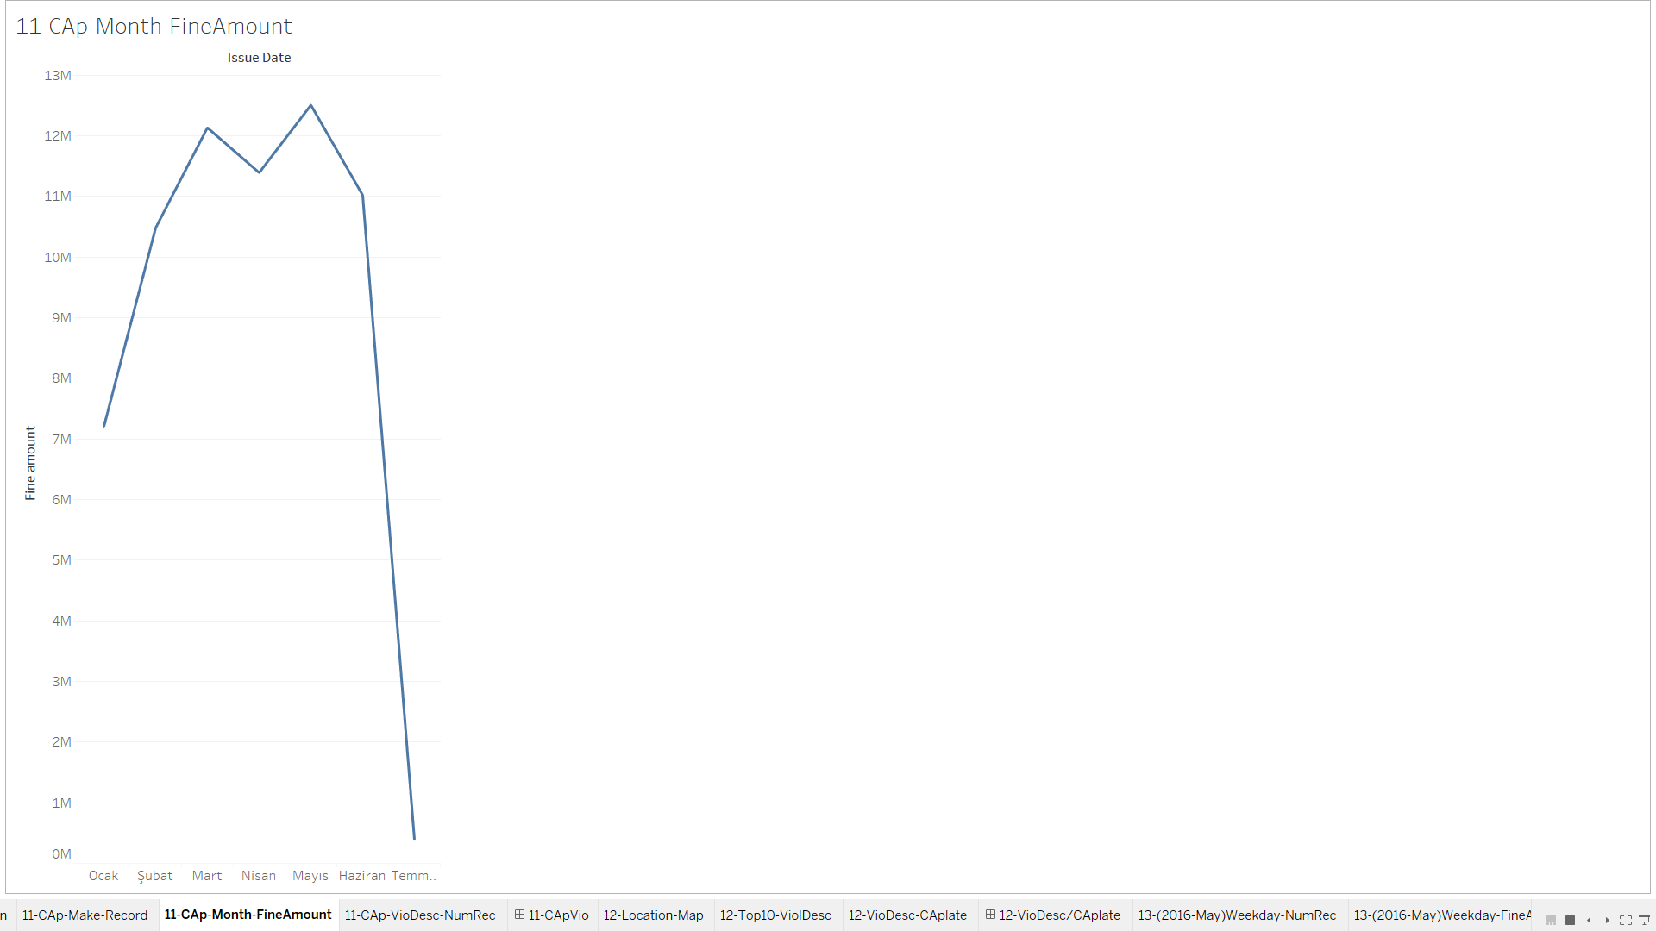

11.3- Cap-VioDesc-NumRec

This sheet allows us to filter by vehicle plate and shows us the violation names, we can see that display of tabs violation mostly accrued by CA plate while it is highly low in none-CA vehicles.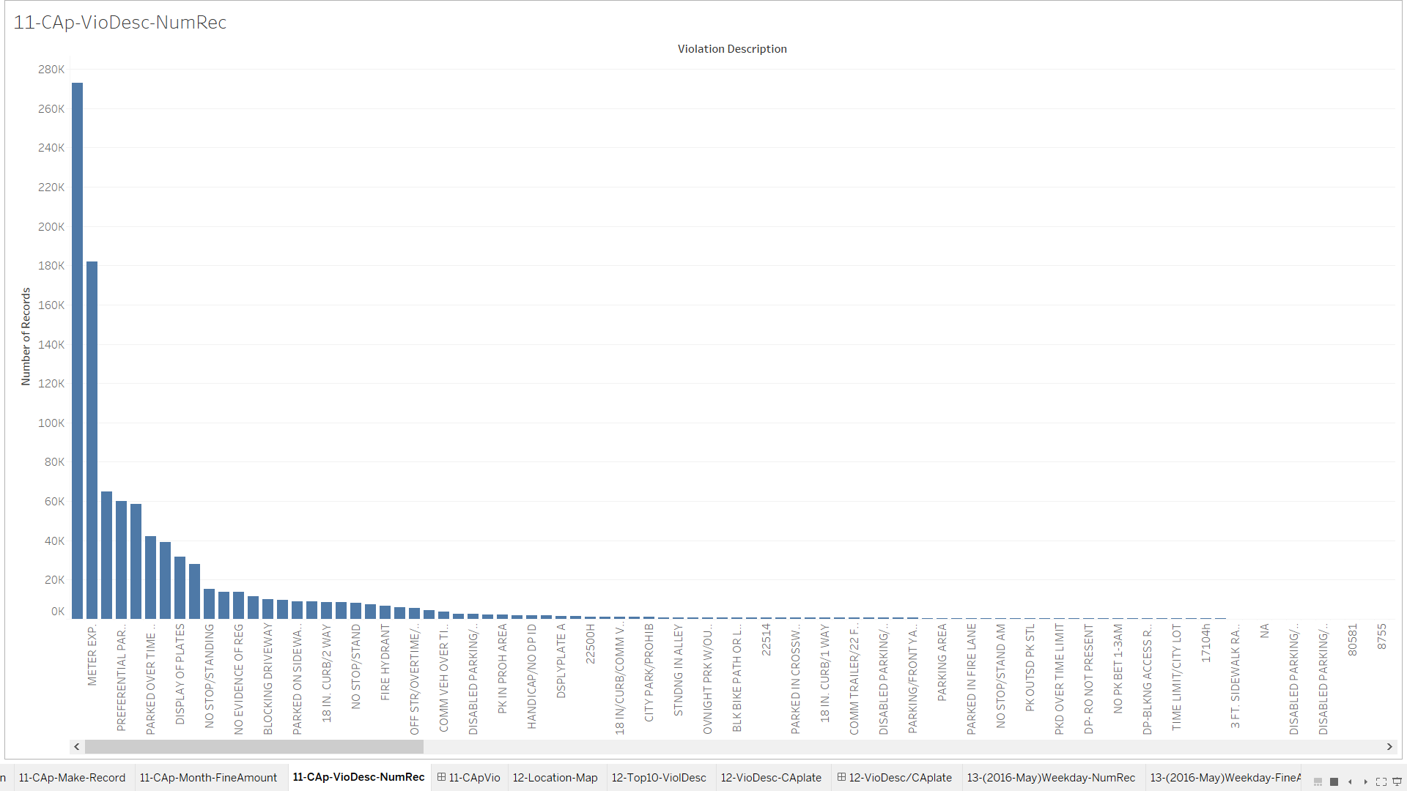

11-CapVio(DashBoard)

This dashboard gives us different types of information about CA plate and None-CA plate vehicles the violation described graph is order according to CA plate violations when we change plate type we can observe the decrement and increase more clear.

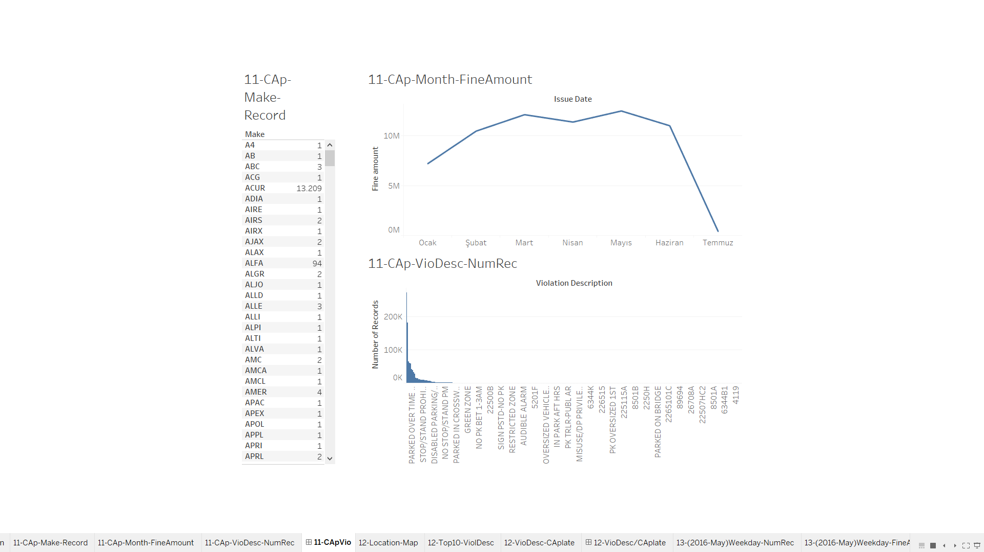

12.1-Location-Map

This sheet shows all locations of the records with street names, We have used mapbox to acquire proper map view.

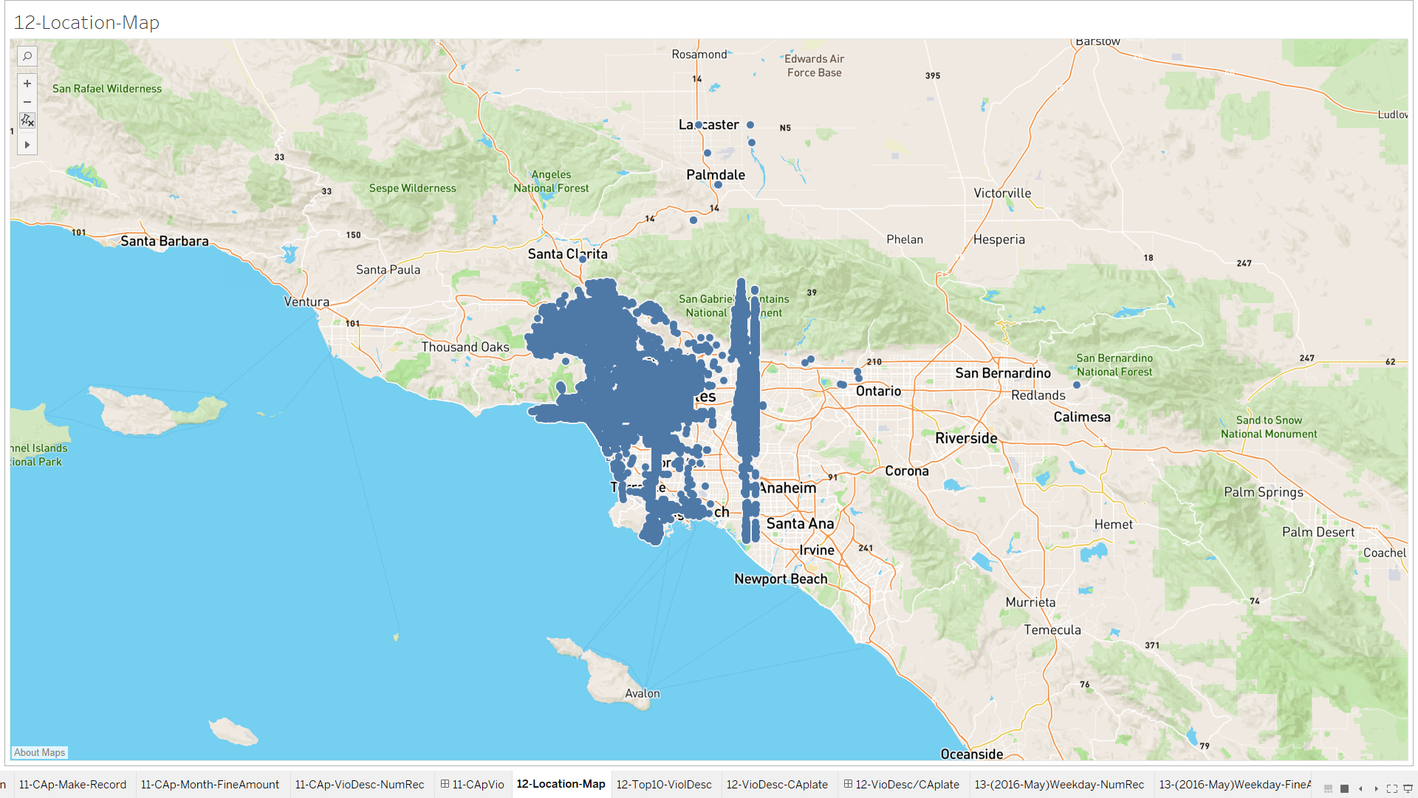

12.2- Top10-VioDesc

The sheet shows top 10 violations with amounts as we can see there is huge differences between first and second violation.

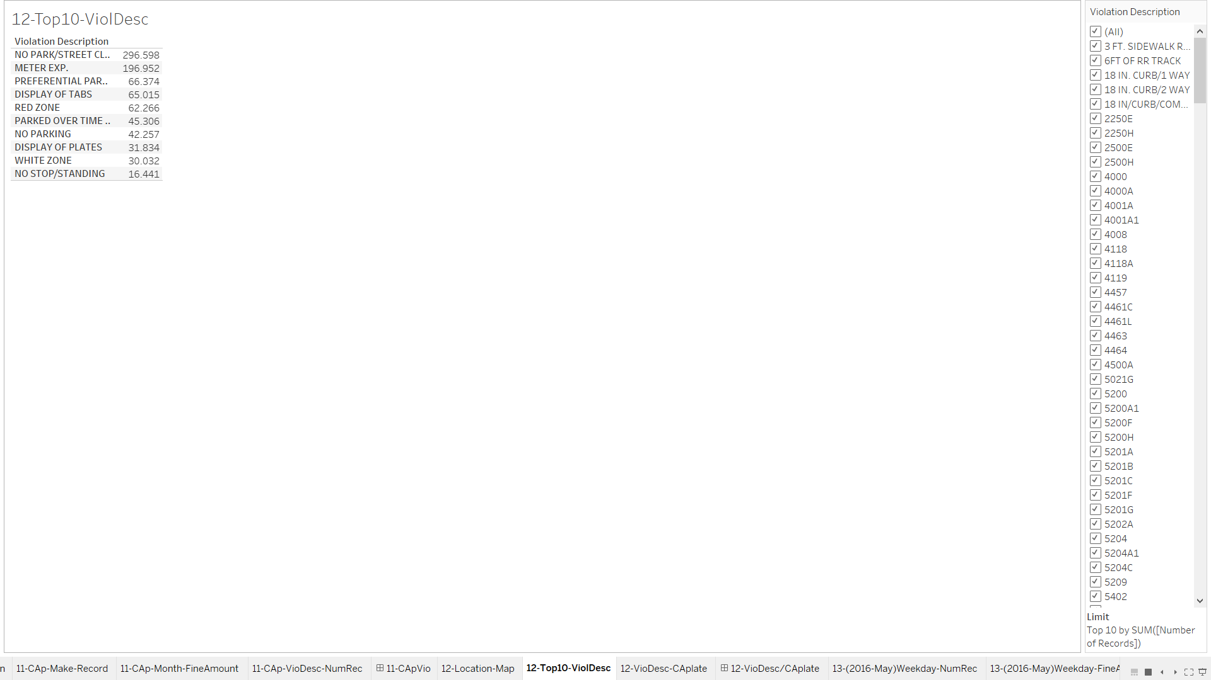

12.3-VioDesc-CAplate

We can observe the violation differences between locals and others.

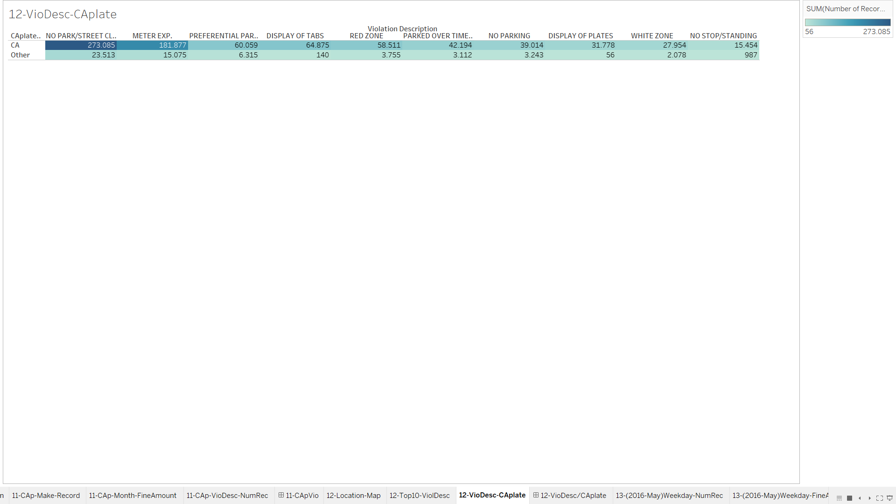

12-VioDesc/CAplate(Dashboard)

This dashboard helps us to visualize CA plate violations occurred areas.

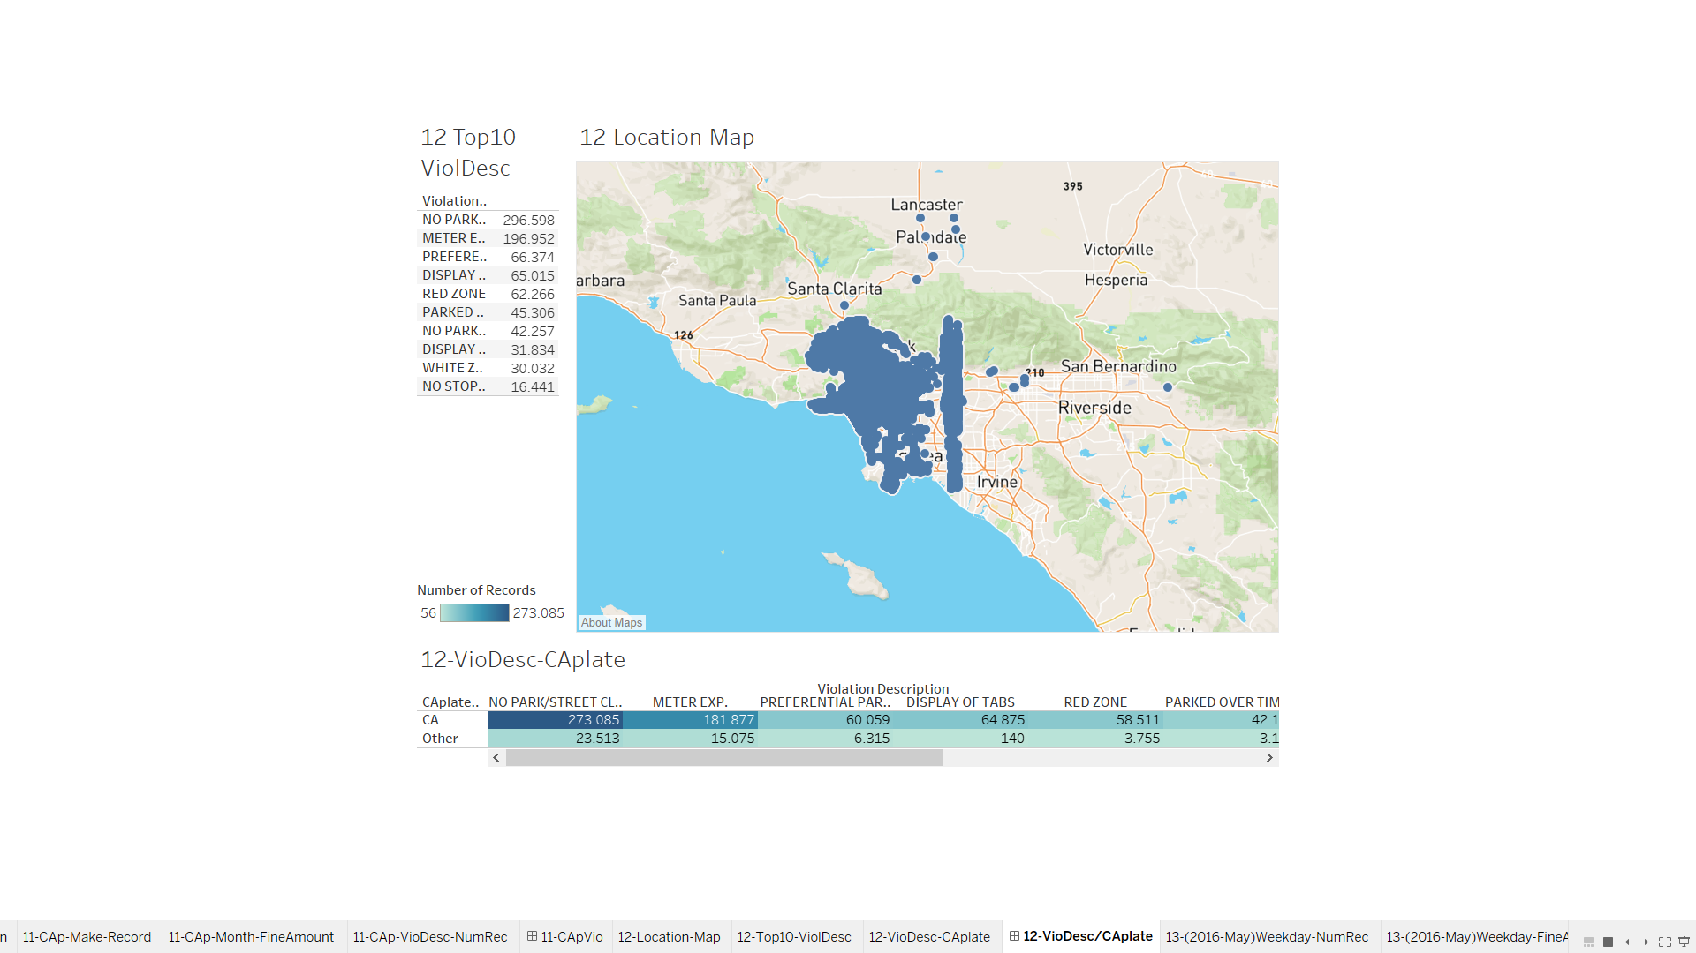

13.1-Weekday-NumRec

This sheet shows us number of violations occurred during weekdays, while most of the people expect that in weekends these number should peek we observe that the peek is at Tuesday.

In this sheet we have several filters we can observe the changes in multiple months and different years.

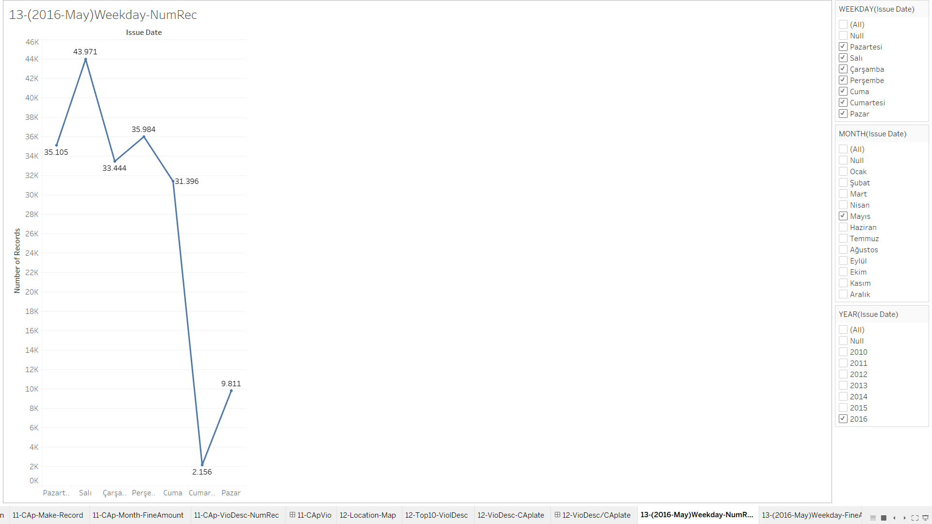

13.2- Weekday-FineAmount

The total fine amount is not totally related to number of records, so we created this sheet to observe fine amount among the days.

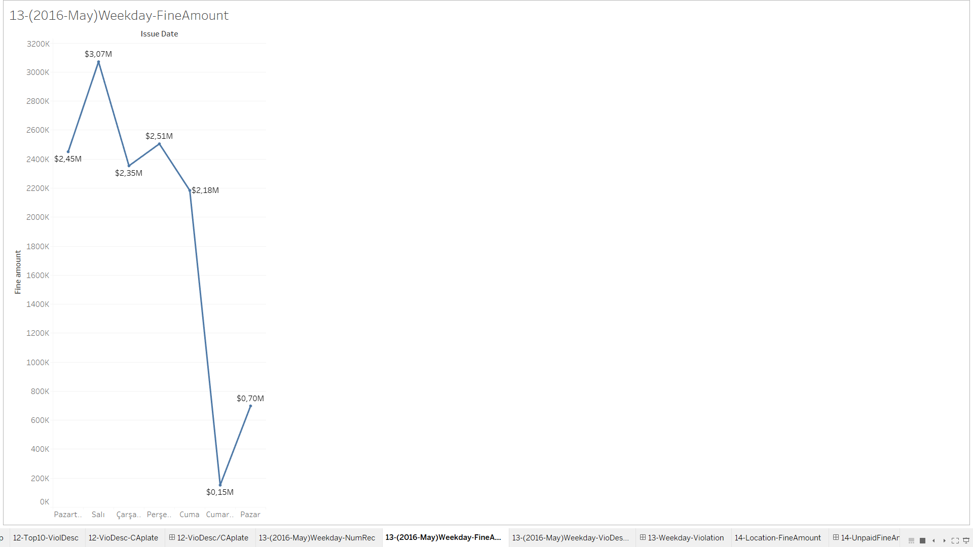

13.3-Weekday-VioDesc-NumRec

In this sheet we can observe top10 violations number of records, and to see if there is a violation occurred constantly, higher than the others.

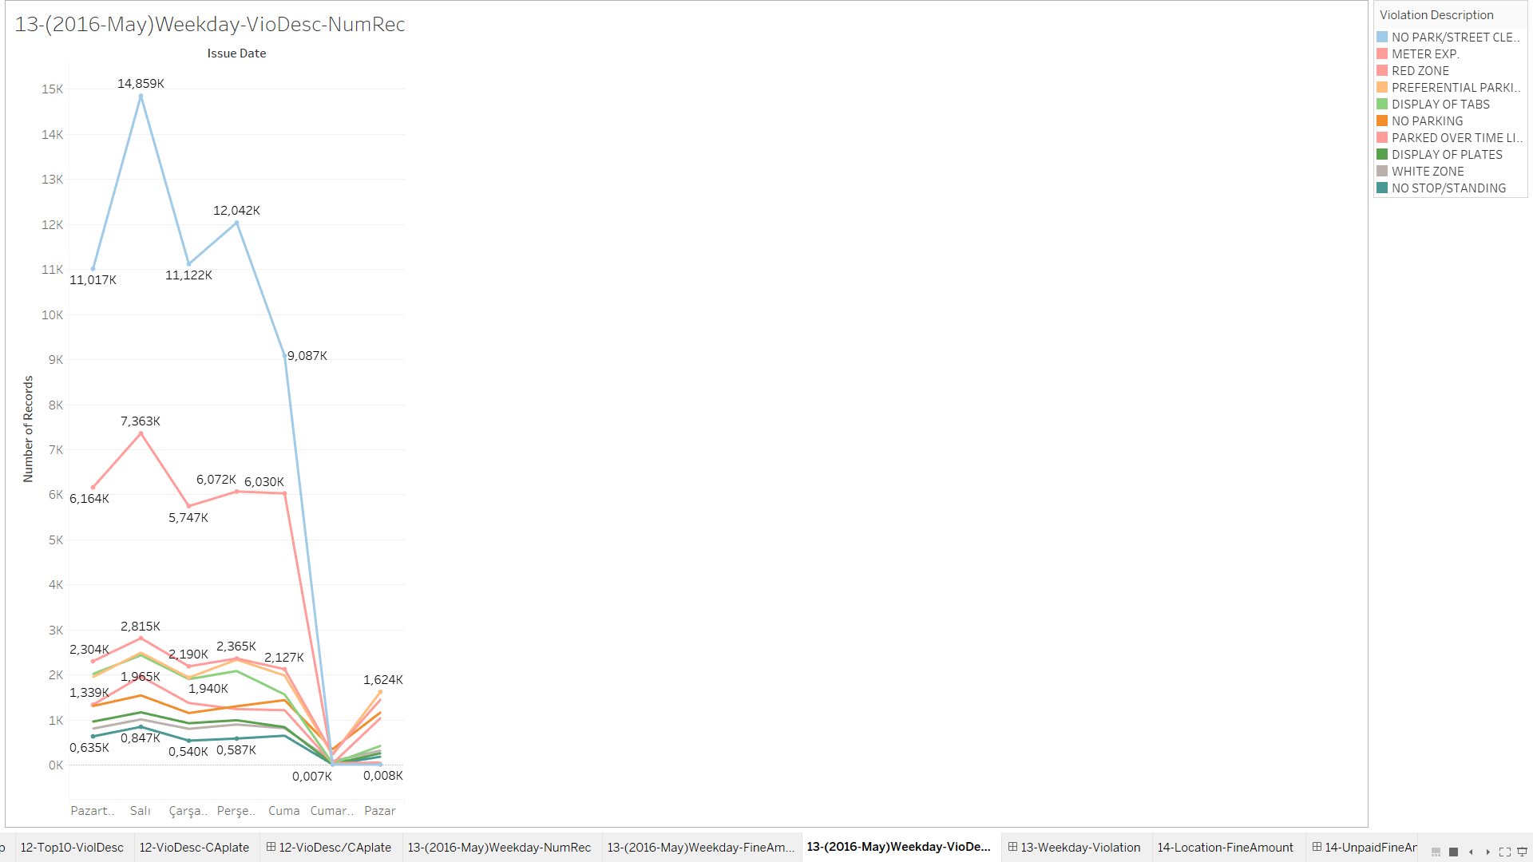

13-Weekday-VioDesc-NumRec(Dashboard)

The dashboard consist of 3 sheets and all sheets contains line graph, we have multiple filter options and also we can filter the dashboard from graphs which allows us to focus more detailed analysis.

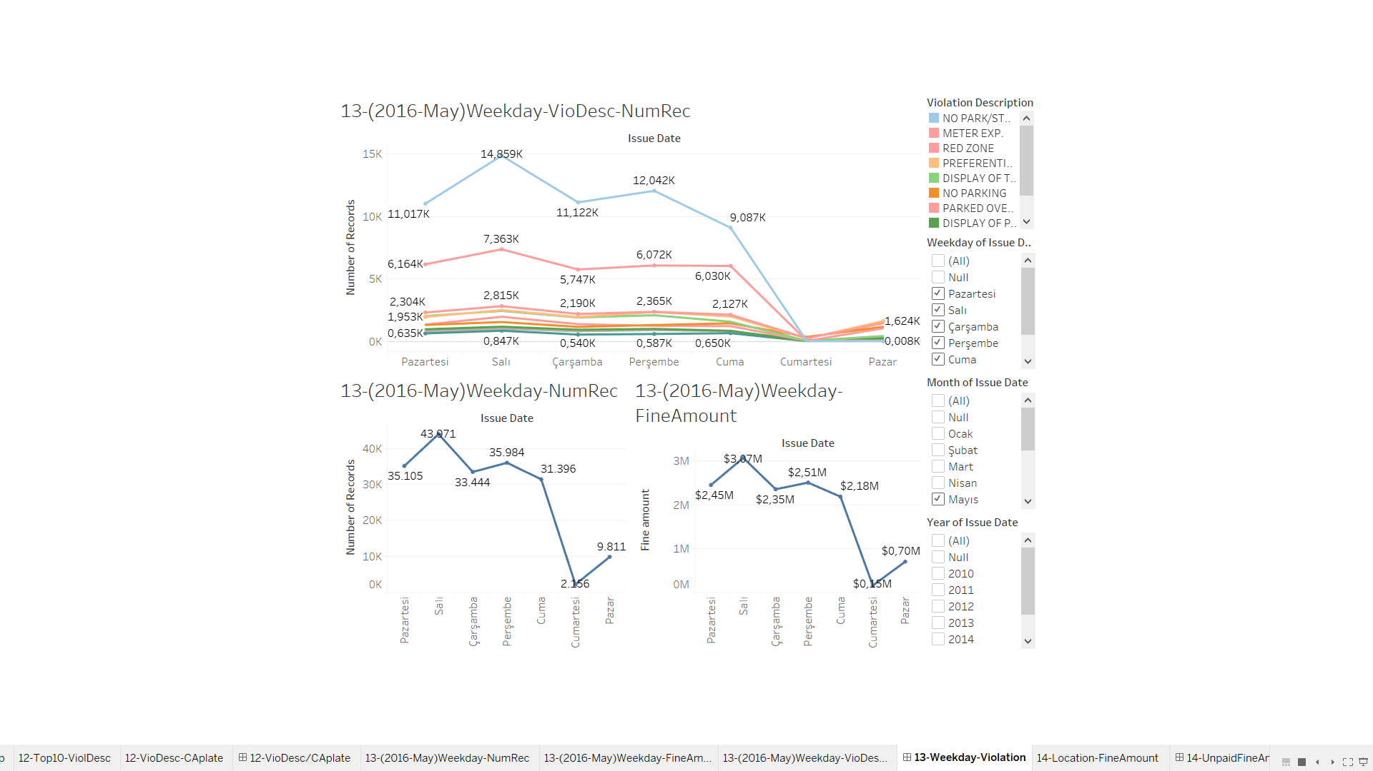

14.1- LocationFineAmount

We can filter this sheet by changing fine amount and we make multiple choices.

As in the images we can observe the locations of the records that haven’t defined fine amount.

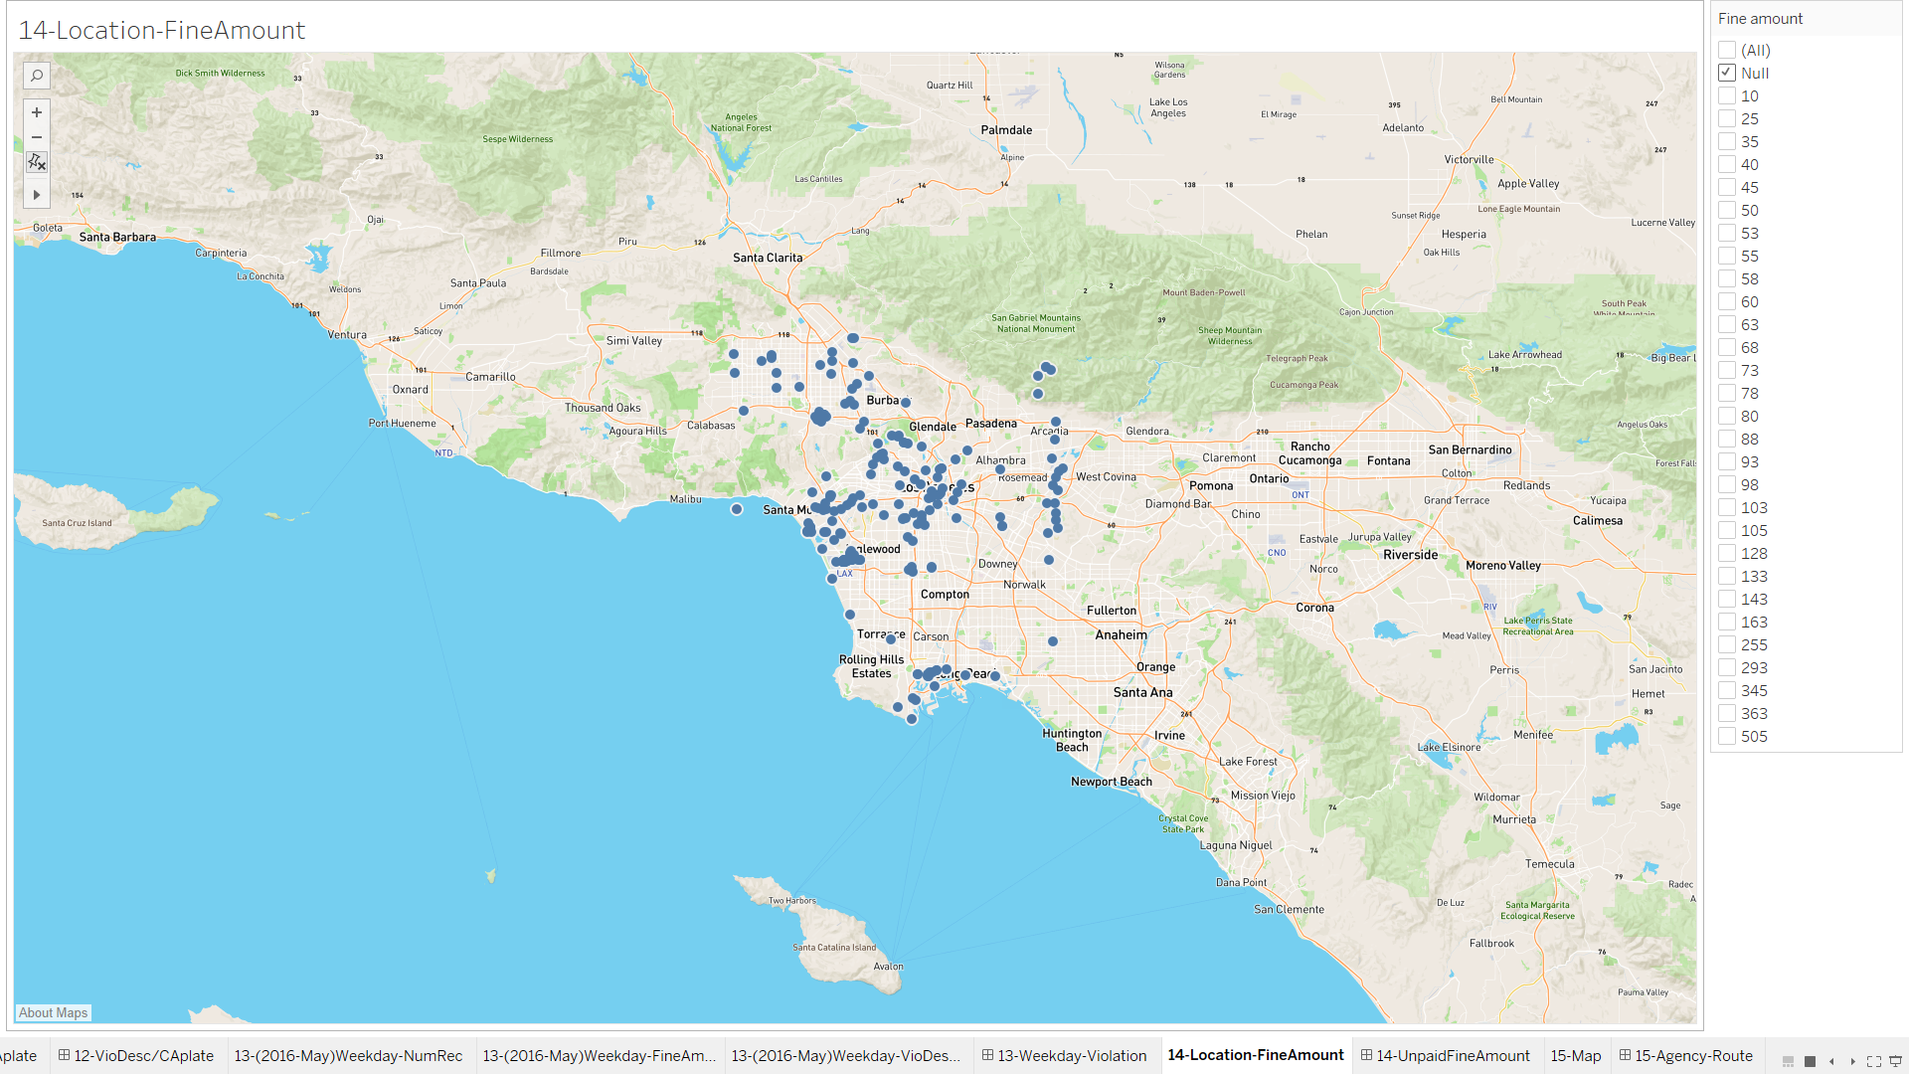

14-LocationFineAmount(Dashboard)

In this dashboard one of the observation we can see is which record doesn’t have fine amount defined and what type of vehicles fine amount have been neglected; mostly which days. By changing various variables we can achieve interesting results.

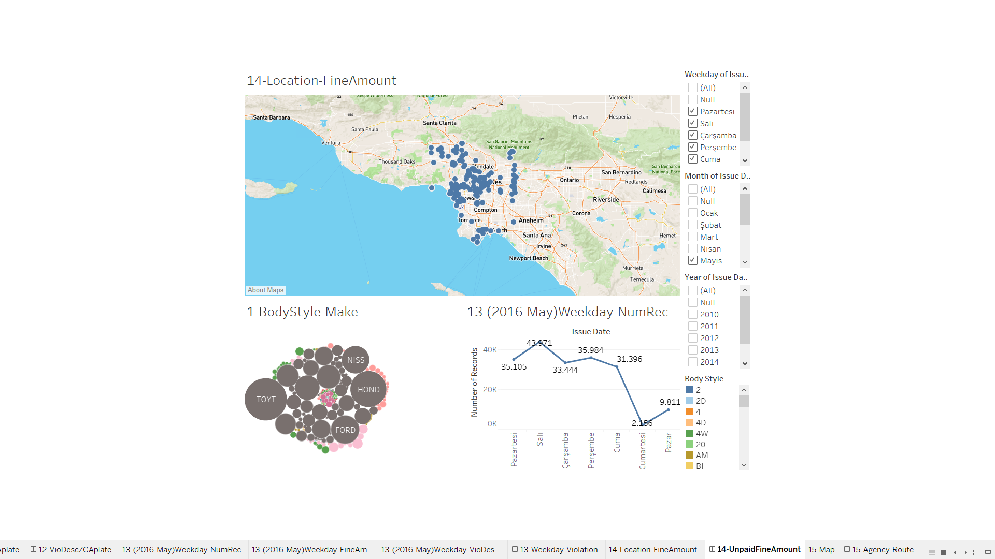

15.1-Map

In this sheet we can observe the number of records in street, the bigger the circle the more records we have in that street.

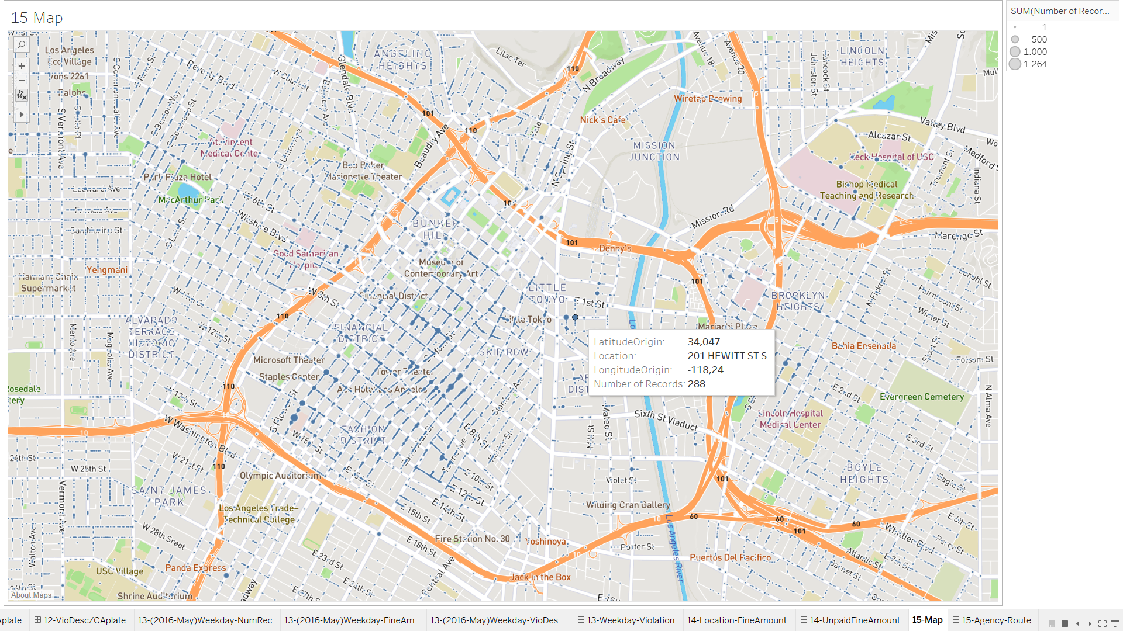

15-Agency-Route(Dashboard)

In this dashboard we can see the streets that agencies take records, we can find a pattern of the agencies movements we can also filter by interacting with map and graph which gives us more certain results. By looking other dashboard we can figure out if the agency is recording only specific violations.

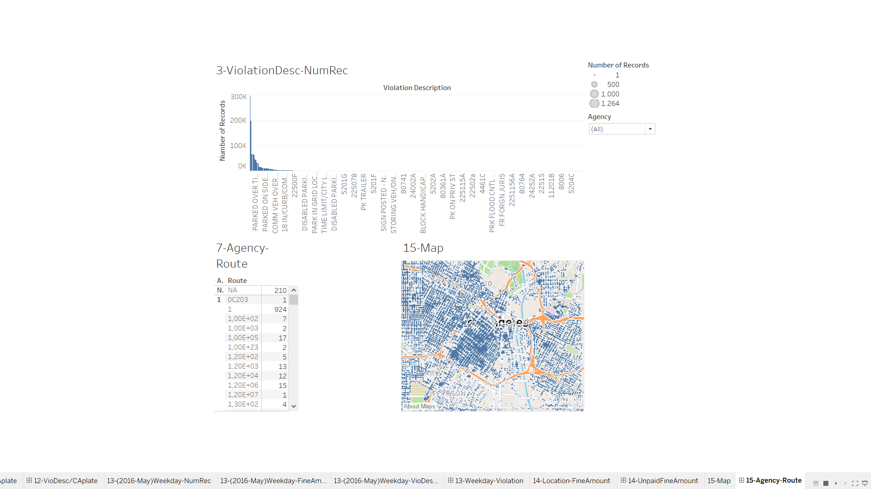

PART2

In the dashboard we have gain some insight from dataset like we can see that in 2016 at May has the most violation records among time series and while we were expecting to have more violations in weekends we saw that in week Tuesday have the most violation record. Our analysis shows us that most of the agencies citation records are in certain area and also we can see which agency have the most citation and the average of their fine amount.

The questions that our client can ask are:

Is there relation between vehicle makes and violation description?

Does a specific colored vehicle tend to violet certain rules?

Is there relation between vehicle color and locals?

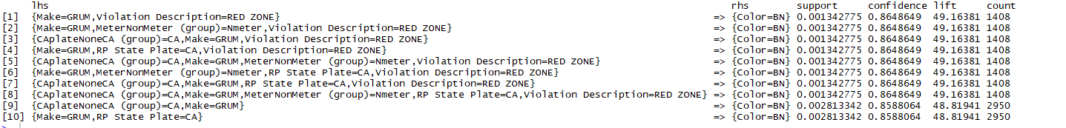To find the relations between our attributes we have inserted our dataset to apriority algorithm.

Our results shows that make, violation Description, CA plate, MeterNMeter have relation.

Our first dashboard shows the location of records which satisfied the rules.

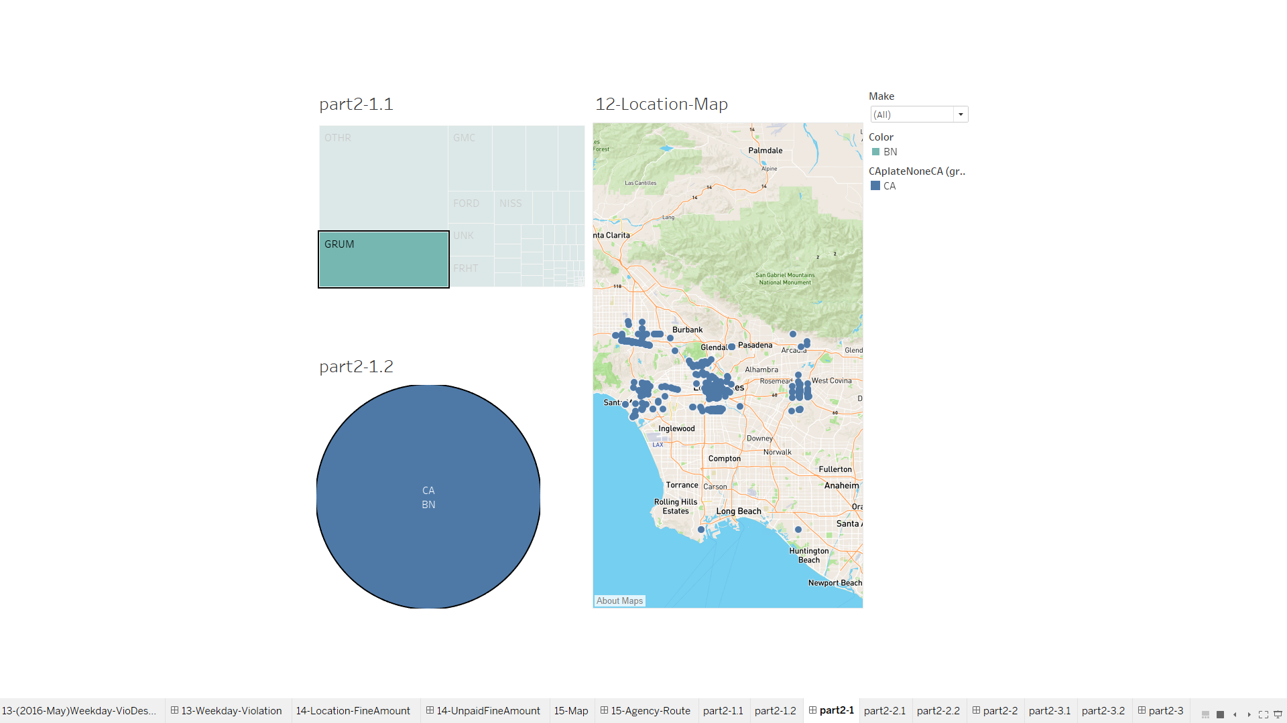

In this second dashboard we used make and violation rule to see if we will achieve the same result in our algorithm, we can see the number of records that satisfy our condition is 1628,and number of records that vehicle color is BN. 1408/1628 = 0,86 shows us that the rule we found is correct.

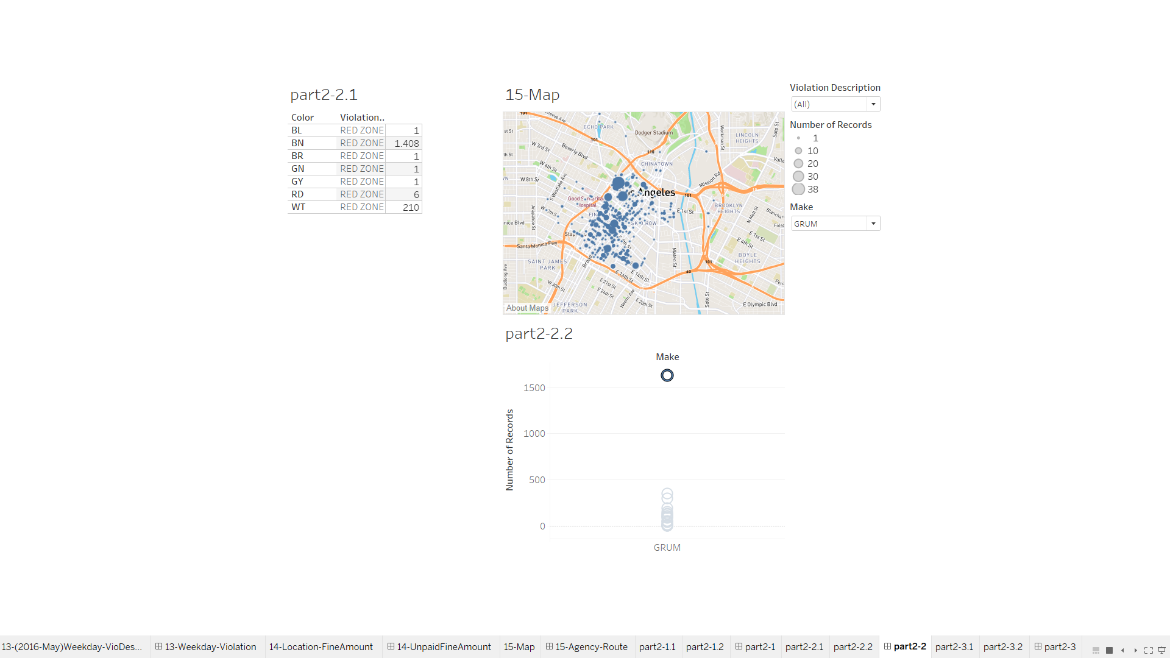

In our last dashboard

We have used park meter to see if we can satisfy the second rule by using same attributes that the rule require and our results supports the correctness of the rules.

